Agriculture, Forestry, and Fisheries: Understanding Food Security in Guatemala[1]

*How natural capital accounting revealed that a country that feeds on maize and beans leaves the production of these crops entirely up to climate variability.*

Table of Contents

What is an Agriculture, Forestry, and Fisheries account? 1

And what kind of information does it contain? 2

Has it already been put together for Guatemala? 2

What do we know about crops then? 2

How important is the food processing industry? 4

What do we know about water and energy use in this context? 6

What happens with fertilizers and nutrients in Guatemala? 8

What do we know about the economics of it all? 10

Final thoughts 12

References: 13

## What is an Agriculture, Forestry, and Fisheries account?

The System of Environmental-Economic Accounting for Agriculture, Forestry and Fisheries (SEEA AFF) is a framework that describes the relationship between the environment and the economy with an emphasis on agriculture, forestry and fisheries (FAO, 2015).

On the one hand, it allows us to determine the level of stocks that are present in the production, processing and consumption of food, and other environmental services ascribed to agriculture, forestry, and fisheries. It also tracks the flows of natural inputs between the environment and the economy, as well as within the economy of these and other sectors. Finally, it also reflects environmental degradation that can occur from these exchanges.

## And what kind of information does it contain?

The SEEA AFF aims to keep track of the following data domains and base accounts:

* Agricultural products and related environmental assets
* Forestry products and related environmental assets
* Fisheries products and related environmental assets
* Water resources
* Energy
* Greenhouse Gas GHG emissions
* Fertilizers, nutrient flows and pesticides
* Nitrogen and phosphorous budgets
* Land
* Soil resources
* Other economic data

## Has it already been put together for Guatemala?

Guatemala became one of the test cases of SEEA AFF and we conducted a pilot compilation with existing information of the SEEA Central Framework already present for 2010, in order to assess what was possible and identify information gaps on which more detailed work is needed. Nonetheless, some of the preliminary findings are already revealing.

## What do we know about crops then?

For example, table 1 shows the output and import of various crops in metric tons for Guatemala in 2010. In terms of volume, sugar cane was by far the largest output of this group of products, followed by the production of bananas and maize. But if we were to take out sugar cane and bananas from this comparison because of their highly industrialized nature geared towards exports, we could quickly see that maize took up a third of the remaining products combined supply. Maize was followed closely by the group called “other vegetables” with a share of output of 16% and “other fruits” with 12% of this more limited group (without sugar cane and bananas).

It is also interesting to see that the production of beans, which are a staple food for Guatemalans, was not as large in terms of volume as that of maize. It represented 5% of total supply, which was comparable to wheat (6%), potatoes (6%), and other seeds and oily fruits (5%).

The external dependence of several products is also noteworthy. For example, most wheat was imported (99.7%). Also, 70% of unprocessed rice came from imports also. In as much as maize has been a part of the Guatemalan diet for centuries, about 21% of it was imported. And even if supply of soy might not be important in terms of volume, a third of it came from imports.

***Table 1. Physical supply account for crops in 2010. (metric tons)***

|  |  |  |  |  |
| --- | --- | --- | --- | --- |
|  | Agricultural industries | Manufactures, utilities, and services | Imports | Total |
| Coffee, not roasted, not decaffeinated | 242,595 | 244 | 39 | 242,877 |
| Bananas | 2,637,570 | 0 | 2,136 | 2,639,706 |
| Maize (corn) | 2,327,800 | 1 | 630,100 | 2,957,901 |
| Rice, not husked | 29,593 | 0 | 67,585 | 97,177 |
| Wheat and meslin | 1,493 | 0 | 492,356 | 493,849 |
| Beans | 441,066 | 0 | 23,900 | 464,966 |
| Other vegetables, fresh or chilled n.e.c. | 1,362,470 | 0 | 32,030 | 1,394,501 |
| Other fruits | 984,820 | 64 | 84,264 | 1,069,148 |
| Soybeans | 7,755 | 0 | 3,813 | 11,569 |
| Sugar cane | 19,364,100 | 4,232 | 0 | 19,368,332 |
| All other crops | 1,946,607 | 3,443 | 89,556 | 2,039,605 |
| Total | 27,399,262 | 4,540 | 1,336,224 | 28,740,025 |

Source: Iarna/Banguat (2010)

In terms of use of the same products, we grouped economic activities in a way that would make it more easy to identify the various steps in the food production chain. For that reason, we have industries that use crops as seed inputs, others that use it as animal feed, the food processing industry, hotels and restaurants, and the remaining industries of Guatemala, along with households and exports.

The decision to group industries that would naturally use crops as feed for animals had the intention of addressing the concern of large portions of the earth’s surface being cleared for the production of animal food. Figure 1 shows that the largest users of agricultural supply were manufactures, households, and the rest of the world (exports); not industries for feed. The figure is color coded in a way that makes evident the column with the biggest use share for each product showing in a darker blue. It would be reasonable to think that grain would be used by manufactures for the production of animal foods, but as we’ll see later, volumes of those products were not relevant in the data. In the case of “soybeans” the data revealed that there was no use as feed, but an important share of their volume was used as seed (40%).

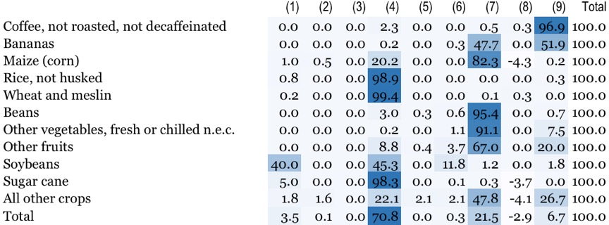

(1) Agricultural industries that use crops as seed; (2 Agricultural industries that use crops as feed; (3) Other agricultural industries; (4) Food processing industries; (5) Other industries; (6) Hotels and restaurants; (7) Households; (8) Stock variation; (9) Exports

***Figure 1. Physical use account for crops in 2010 (percentages)***

## How important is the food processing industry?

It is interesting to pay attention to the share of some products that is used by the food processing industry at the national level (in the manufactures column). For example, in the case of maize, only 20% of all used volume had a final destination in the food processing industries. This is consistent with the 80% (adjusted to extract the negative stock variation) that was consumed by households. It contrasts with the 99% of the supply of unprocessed rice and wheat that was used almost exclusively by the food processing industries. This does not mean that households didn’t consume these products. It only means that they did so in their processed versions, such as precooked white rice and dehydrated breakfast gruel. As an example of this, the totality of sugar cane was used by the food processing industry.

Aside from these exceptions, households did consume large volumes of cultivated products directly, which is consistent with the traditional market culture still present in most of the country. For example, they used 95% of beans, 88% of potatoes, 97% of other roots and tubers, 99% of fresh culinary herbs, 91% of other vegetables and 67% of all fruits, among others.

***Table 2. Supply of processed foods. (metric tons)***

|  |  |  |  |  |
| --- | --- | --- | --- | --- |
|  | Agricultural industries | Manufactures, utilities, and services | Imports | Total |
| Legumes and other preserved vegetables | 0 | 0 | 35,039 | 35,039 |
| Fruit juices and vegetable juices | 0 | 29,374 | 23,523 | 52,897 |
| Fruit and nuts | 0 | 2,853 | 401 | 3,254 |
| Jams, fruit jellies and fruit or nut puree | 0 | 16,331 | 15,260 | 31,592 |
| Other preserved fruits | 0 | 45 | 0 | 45 |
| Vegetable oil | 0 | 61,248 | 125,167 | 186,415 |
| Vegetable fats (except maize oil) | 0 | 0 | 0 | 0 |
| Margarine and similar preparations | 0 | 2,281 | 8,656 | 10,937 |
| Flours and meals of oil seeds or oleaginous fruits | 0 | 0 | 368,656 | 368,656 |
| Husked rice | 0 | 0 | 3,457 | 3,457 |
| Wheat or meslin flour | 0 | 0 | 17,210 | 17,210 |
| Cereal flours other than of wheat or meslin | 0 | 0 | 114,942 | 114,942 |
| Preparations used in animal feeding n.e.c. | 0 | 18,367 | 33,559 | 51,926 |
| Crispbread; rusks, toasted bread and similar toasted products | 0 | 1,680 | 11 | 1,691 |
| Gingerbread and the like; sweet biscuits; waffles and wafers | 0 | 10,313 | 34,571 | 44,885 |
| Raw cane or beet sugar | 0 | 1,743,340 | 28 | 1,743,368 |
| Refined cane or beet sugar, in solid form, containing added flavouring or colouring matter | 0 | 0 | 175 | 175 |
| Molasses | 0 | 304,311 | 1,129 | 305,440 |
| Sugar confectionery (including white chocolate), not containing cocoa | 0 | 0 | 0 | 0 |
| Uncooked pasta, not stuffed or otherwise prepared | 0 | 12,194 | 8,558 | 20,752 |
| Total | 0 | 2,202,337 | 790,342 | 2,992,680 |

Source: Iarna/Banguat (2010)

Also, we take note of the relative importance in terms of volume of fruit juices (52,897 tm), other bakery and pastry products (44,885 tm), preserves, fruit marmalades, purees and fruit pastes (31,592 tm), as well as that of prepared or canned legumes (35,039 tm). We can find canned refried beans in this last category, which have become increasingly popular in the Guatemalan diet.

As illustrative as the supply of foods is in understanding food security topics, evaluating the use of those foods within the economy has more explanatory power. Table 3 shows that households consume about 23% of the volume of prepared legumes, while 68% becomes exports, and it also shows that they use about 73% of canned fruits. It is also relevant that only 36% of processed rice goes to households, while 62% becomes exports. Households also use about 20% of wheat flour and 60% of other types of flour.

***Table 3. Use of processed foods. (metric tons)***

|  |  |  |  |  |  |  |  |  |
| --- | --- | --- | --- | --- | --- | --- | --- | --- |
|  | (1) | (2) | (3) | (4) | (5) | (6) | (7) | Total |
| Legumes and other preserved vegetables | 0 | 2,117 | 1 | 170 | 8,100 | 612 | 24,039 | 35,039 |
| Fruit juices and vegetable juices | 0 | 0 | 0 | 0 | 0 | 0 | 52,897 | 52,897 |
| Fruit and nuts | 0 | 0 | 0 | 0 | 0 | 0 | 3,254 | 3,254 |
| Jams, fruit jellies and fruit or nut puree | 0 | 0 | 0 | 0 | 0 | 0 | 31,592 | 31,592 |
| Other preserved fruits | 0 | 7 | 0 | 2 | 33 | 3 | 0 | 45 |
| Vegetable oil | 0 | 0 | 0 | 0 | 0 | 0 | 186,415 | 186,415 |
| Vegetable fats (except maize oil) | 0 | 0 | 0 | 0 | 0 | 0 | 0 | 0 |
| Margarine and similar preparations | 0 | 0 | 0 | 0 | 0 | 0 | 10,937 | 10,937 |
| Flours and meals of oil seeds or oleaginous fruits | 0 | 236,062 | 14,123 | 75,642 | 12,951 | 7,288 | 22,589 | 368,656 |
| Husked rice | 0 | 21 | 1 | 85 | 1,257 | -38 | 2,131 | 3,457 |
| Wheat or meslin flour | 0 | 4,716 | 1 | 33 | 3,358 | 34 | 9,069 | 17,210 |
| Cereal flours other than of wheat or meslin | 0 | 9,463 | 736 | 81 | 70,259 | 2,275 | 32,128 | 114,942 |
| Preparations used in animal feeding n.e.c. | 0 | 0 | 0 | 0 | 0 | 0 | 51,926 | 51,926 |
| Crispbread; rusks, toasted bread and similar toasted products | 0 | 0 | 0 | 0 | 0 | 0 | 1,691 | 1,691 |
| Gingerbread and the like; sweet biscuits; waffles and wafers | 0 | 0 | 0 | 0 | 0 | 0 | 44,885 | 44,885 |
| Raw cane or beet sugar | 0 | 0 | 0 | 0 | 0 | 0 | 1,743,360 | 1,743,360 |
| Refined cane or beet sugar, in solid form, containing added flavouring or colouring matter | 0 | 4 | 2 | 0 | 23 | -4 | 149 | 175 |
| Molasses | 0 | 0 | 0 | 0 | 0 | 0 | 305,440 | 305,440 |
| Sugar confectionery (including white chocolate), not containing cocoa | 0 | 0 | 0 | 0 | 0 | 0 | 0 | 0 |
| Other sugars | 0 | 0 | 0 | 0 | 0 | 0 | 0 | 0 |
| Uncooked pasta, not stuffed or otherwise prepared | 0 | 0 | 0 | 0 | 0 | 0 | 20,752 | 20,752 |
| Total | 0 | 252,390 | 14,864 | 76,013 | 95,980 | 10,169 | 2,543,253 | 2,992,671 |

(1) Agricultural industries; (2) Food processing industry; (3); Other manufactures and services; (4) Hotels and restaurants; (5) Households; (6) Stock Variation; (7) Exports

Source: Iarna/Banguat (2010)

## What do we know about water and energy use in this context?

Food production requires that we ensure water availability during the various growth stages of crops. Table 4 shows the different requirements of land and water for crops. Among uses of water it is important to distinguish between irrigated and rainfed agriculture. In the first case, producers must make sure that there is enough available water of quality for crops to grow. In the second case, producers depend on the availability of rain water, the hydrological cycle, and climate variability.

***Table 4. Land and water use for crops (hectares and million cubic meters)***

|  |  |  |  |  |  |  |  |  |
| --- | --- | --- | --- | --- | --- | --- | --- | --- |
|  | (1) | (2) | (3) | (4) | (5) | (6) | (7) | (8) |
| Coffee | 250,096 | 2,569.7 | 0.0 | 0.0 | 0.0 | 0.0 | 0.0 | 2,569.7 |
| Bananas | 63,585 | 535.8 | 341.1 | 0.0 | 477.5 | 79.6 | 898.2 | 1,434.0 |
| Maize | 825,424 | 4,819.4 | 0.0 | 0.0 | 0.0 | 0.0 | 0.0 | 4,819.4 |
| Palm oil tree | 100,000 | 1,360.7 | 627.3 | 47.1 | 734.0 | 106.1 | 1,514.5 | 2,875.2 |
| Beans | 354,092 | 931.6 | 0.0 | 0.0 | 0.0 | 0.0 | 0.0 | 931.6 |
| Sugar cane | 241,500 | 2,698.0 | 1,129.7 | 16.8 | 805.2 | 161.8 | 2,113.5 | 4,811.5 |
| All other crops | 1,236,786 | 2,267.9 | 589.0 | 204.7 | 399.4 | 240.4 | 1,433.5 | 3,701.3 |
| Total | 3,071,482 | 15,183 | 2,687 | 269 | 2,416 | 588 | 5,960 | 21,143 |

(1) Cultivated area (ha); (2) Rainfed water use (m3); (3) Aspersion (m3); (4) Drip irrigation (m3); (5) Other irrigation methods (m3); (6) Total irrigation (m3); (7) Total water use (rainfed + total irrigation) (m3)

Source: Iarna/Banguat (2010)

Maize production, as we’ve seen in terms of volume before, is highly important to Guatemalans. It represents also the largest water use among crops (4.8 million m3), which is comparable to that of sugar cane production. Nonetheless, the water used for the production of this crop comes exclusively from rain (rainfed agriculture). This is also the case for the production of beans, whose water use reaches 0.9 million m3.

Similarly, sugar cane has also a total water use of 4.8 million m3. This is, however, a more industrialized production which uses several methods of water provision: 56% rainfed, 24% aspersion, 17% gravity, and 3% other methods.

Other relevant uses of water correspond with palm oil tree production (2.9 million m3, 52% of which come from irrigation), coffee (2.6 million m3, all rainfed agriculture) and bananas (1.4 million m3, 63% of which comes from irrigation).

Table 5 shows the use of energy of various sources in Guatemala. It is interesting that agricultural production, which does use a certain amount of gasoline and diesel, only represents about 1% of total energy use in the country.

It is more relevant to note that households use about 40% of the country’s total energy use in the form of fuelwood. Judging by the 1% of total energy use that represent household gas or electricity use, it is implied that the main method of cooking in Guatemala is fuelwood.

***Table 5. Energy use (Terajoules)***

|  |  |  |  |  |  |  |  |  |  |  |  |  |
| --- | --- | --- | --- | --- | --- | --- | --- | --- | --- | --- | --- | --- |
|  | (1) | (2) | (3) | (4) | (5) | (6) | (7) | (8) | (9) | (10) | (11) | Total |
| Growing of coffee | 0 | 0 | 0 | 199 | 395 | 0 | 0 | 0 | 0 | 0 | 139 | 733 |
| Growing of bananas | 0 | 0 | 0 | 69 | 150 | 0 | 0 | 0 | 0 | 0 | 0 | 219 |
| Growing of cardamum | 0 | 0 | 0 | 70 | 46 | 0 | 0 | 0 | 0 | 0 | 0 | 116 |
| Growing of cereals | 0 | 0 | 0 | 163 | 1,067 | 0 | 0 | 0 | 0 | 0 | 0 | 1,230 |
| Grwoing of roots and tubers | 0 | 0 | 0 | 141 | 730 | 0 | 0 | 0 | 0 | 0 | 0 | 871 |
| Growing of fruits and nuts | 0 | 0 | 0 | 120 | 319 | 0 | 0 | 0 | 0 | 0 | 0 | 439 |
| Other crops | 0 | 0 | 0 | 60 | 159 | 0 | 0 | 0 | 0 | 0 | 0 | 219 |
| Cattle farming | 0 | 0 | 0 | 56 | 1,327 | 0 | 0 | 0 | 0 | 0 | 276 | 1,659 |
| Forestry | 0 | 0 | 0 | 130 | 890 | 0 | 0 | 0 | 0 | 0 | 0 | 1,019 |
| Fisheries | 0 | 0 | 0 | 74 | 103 | 0 | 0 | 0 | 0 | 0 | 0 | 177 |
| Manufactures, mining | 38,008 | 2,829 | 19,988 | 7,406 | 14,628 | 8,310 | 0 | 2,706 | 3,989 | 0 | 7,252 | 105,114 |
| Utilities | 0 | 0 | 13,856 | 97 | 1,927 | 13,634 | 828 | 0 | 1,608 | 40,980 | 1,242 | 74,173 |
| Other economic industries and services | 1,304 | 0 | 335 | 10,925 | 30,271 | 695 | 1,839 | 628 | 640 | 0 | 13,441 | 60,078 |
| Households | 208,070 | 0 | 0 | 22,808 | 2,366 | 0 | 706 | 6,945 | 132 | 0 | 6,649 | 247,676 |
| Exports | 0 | 21,656 | 0 | 0 | 0 | 0 | 0 | 0 | 0 | 0 | 474 | 22,129 |
| Stock variation | 0 | 918 | 0 | 2,099 | -1,405 | 1,163 | -73 | 4,281 | -2,246 | 0 | 0 | 4,737 |
| Total | 247,382 | 25,403 | 34,179 | 44,417 | 52,970 | 23,803 | 3,300 | 14,560 | 4,124 | 40,980 | 29,472 | 520,588 |

(1) Fuelwood; (2) Crude oil; (3) Coal; (4) Gasoline; (5) Gas oil (diesel); (6) Fuel oil and bunker; (7) Kerosene; (8) Liquefied petroleum gas; (9) Oil derivatives; (10) Bagass; (11) Electricity

Source: Iarna/Banguat (2010)

## What happens with fertilizers and nutrients in Guatemala?

Statistical work on the use of fertilizers is at a very early stage in Guatemala and so it can be complicated to supply information in the format proposed by the SEEA AFF manual. However there are some estimations by FAO. For them:

“Fertilizer consumption measures the quantity of plant nutrients used per unit of arable land. Fertilizer products cover nitrogenous, potash, and phosphate fertilizers (including ground rock phosphate). Traditional nutrients–animal and plant manures–are not included. For the purpose of data dissemination, FAO has adopted the concept of a calendar year (January to December). Some countries compile fertilizer data on a calendar year basis, while others are on a split-year basis. Arable land includes land defined by the FAO as land under temporary crops (double-cropped areas are counted once), temporary meadows for mowing or for pasture, land under market or kitchen gardens, and land temporarily fallow. Land abandoned as a result of shifting cultivation is excluded.” (FAO 2016)

The figure below shows a time series of this indicator for the years 2002-2013. We see a growing trend, going from 189 kilograms per hectare in 2010 and reaching 256 kg/ha in 2013.

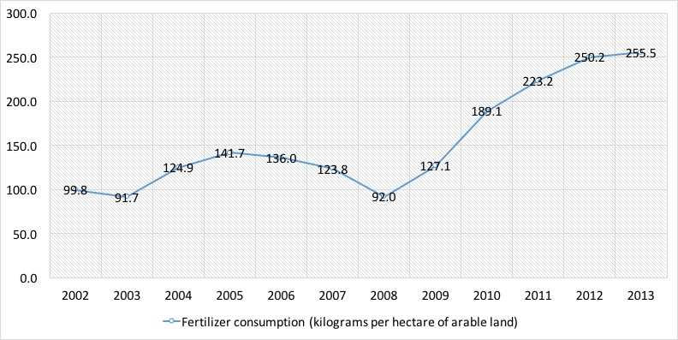

*Figure 2. Fertilizer consumption (kilograms per hectare of arable land)*

There is little data regarding nutrients and waste in the Guatemalan SEEA. However, there is a food balance sheet developed by the National Institute of Statistics for the year 2013, and even if it is impractical to reproduce it here, it is important to note that it has information on internal availability; losses and wastes; internal use; available food per year in metric tons; and supply of food and nutrients per inhabitant for:

1. cereals;
2. legumes;
3. sugars;
4. tubers and roots;
5. vegetables;
6. fruits;
7. meats;
8. eggs;
9. fish and seafood;
10. dairy products;
11. oils and fats;
12. fortified foods.

Figure 3 shows the evolution of the availability of daily calories per capita from vegetal and animal sources. In the years 2005-2013 87% of Guatemalans’ caloric intake came from vegetal sources, and 13% from animal sources, in average.

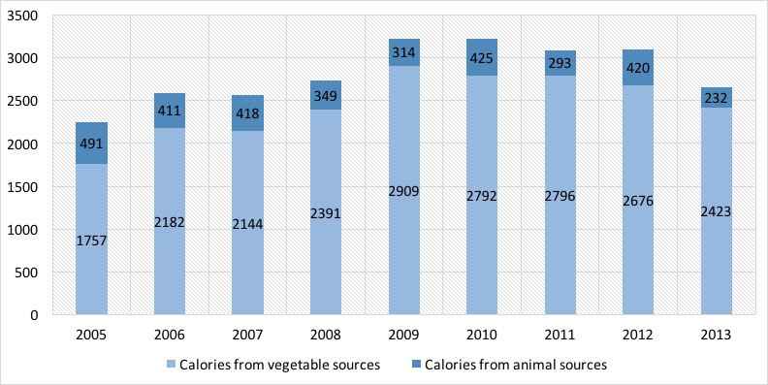

*Figure 3. Total available calories*

## What do we know about the economics of it all?

Table 6 shows the contribution of the different agricultural products to the Guatemalan economy in monetary terms for the year 2010. As we can see, the production of crops contributed around 9% of gross production, while cattle farming about 2%; the same as other agricultural products, forestry, and fisheries combined (2%). In total, all this production represents about 12% of the value added of the entire economy in that year.

***Table 6. Total supply in monetary terms (thousands of quetzales)***

|  |  |  |  |  |  |
| --- | --- | --- | --- | --- | --- |
|  | Output | Imports | Taxes less subsidies | Trade and transportation margins | Total |
| Crops | 32,836 | 3,907 | 273 | 24,129 | 61,145 |
| Cattle farming products | 8,278 | 105 | 0 | 2,123 | 10,507 |
| Other agricultural products | 3,652 | 32 | 20 | 1,254 | 4,958 |
| Forestry | 3,551 | 67 | 1 | 2,782 | 6,401 |
| Fisheries | 882 | 95 | 7 | 491 | 1,474 |
| All other industries | 485,865 | 116,612 | 20,571 | -30,779 | 592,269 |
| Total | 535,063 | 120,819 | 20,872 | 0 | 676,754 |

Source: Iarna/Banguat (2010)

Table 7 shows the use of the same products in monetary terms. Households buy 59% of crops, 80% of other agricultural products, but only 19% of the production of cattle farming. For this last category, 80% is destined to intermediate consumption by other industries. As for fisheries, 42% of total output is bought by households, 37% becomes exports and 20% intermediate consumption.

***Table 7. Total use in monetary terms (thousands of quetzales)***

|  |  |  |  |  |  |
| --- | --- | --- | --- | --- | --- |
|  | Intermediate consumption | Exports | Households | Stock variation | Total |
| Crops | 10,504 | 15,204 | 35,933 | -495 | 61,145 |
| Cattle farming products | 8,367 | 19 | 2,008 | 114 | 10,507 |
| Other agricultural products | 947 | 51 | 3,960 | -1 | 4,958 |
| Forestry | 1,408 | 2,060 | 2,864 | 69 | 6,401 |
| Fisheries | 299 | 544 | 624 | 6 | 1,474 |
| All other industries | 201,298 | 68,070 | 276,242 | 46,659 | 592,269 |
| Total | 222,823 | 85,948 | 321,631 | 46,352 | 676,754 |

Source: Iarna/Banguat (2010)

We now turn to extended production and income accounts for agricultural industries and the rest of the economy. Table 8 shows “taxes less subsidies” which represents monetary flows to the government in the form of taxes; net operating surplus, which is equivalent to profits from all companies; mixed income which is a mixture of self compensation and returns to capital of small business owners; compensation of employees; and value added, which is the total wealth generated by all economic activities in the accounting period.

***Table 8. Extended production accounts (thousands of quetzales)***

|  |  |  |  |  |  |  |
| --- | --- | --- | --- | --- | --- | --- |
|  | Taxes less subsidies | Net operating surplus | Mixed income | Employee compensation | Value added | % of value added |
| Growing of coffee | 3.2 | 1,256.9 | 2,442.8 | 1,015.3 | 4,718.2 | 1.5 |
| Growing of bananas | 2.4 | 2,276.7 | 17.3 | 444.9 | 2,741.3 | 0.9 |
| Growing of cardamum | 5.5 | 615.6 | 1,119.6 | 193.9 | 1,934.6 | 0.6 |
| Growing of cereals | 22.2 | 187.3 | 2,096.2 | 494.3 | 2,799.9 | 0.9 |
| Growing of roots and tubers | 4.6 | 397.0 | 6,498.9 | 838.9 | 7,739.4 | 2.5 |
| Growing of fruits and nuts | 5.6 | 1,588.6 | 1,547.8 | 312.3 | 3,454.2 | 1.1 |
| Other crops | 13.4 | 1,727.6 | 646.8 | 677.8 | 3,065.7 | 1.0 |
| Cattle farming | 2.7 | 2,526.1 | 3,499.0 | 1,213.0 | 7,240.7 | 2.3 |
| Forestry | 9.0 | 228.7 | 1,469.6 | 296.6 | 2,004.0 | 0.6 |
| Fisheries | 6.2 | 441.8 | 113.5 | 77.2 | 638.7 | 0.2 |
| Manufactures, mining | 600.6 | 33,562.0 | 20,898.5 | 28,267.5 | 83,328.6 | 26.7 |
| Utilities | 30.5 | 5,268.6 | 0.1 | 1,437.4 | 6,736.7 | 2.2 |
| Other economic industries and services | 1,331.8 | 86,318.6 | 32,511.5 | 65,676.2 | 185,838.1 | 59.5 |
| Total | 2,037.7 | 136,395.4 | 72,861.6 | 100,945.4 | 312,240.1 | 100.0 |

Source: Iarna/Banguat (2010)

## Final thoughts

We’ve seen how the information readily available from the System of Environmental and Economic Accounts of Guatemala can be used to implement an Agriculture, Forestry, and Fisheries account as proposed by FAO to a certain extent. While there are still a number of aspect that need to be covered by Guatemalan statistical efforts, some of the findings of this pilot implementation are already revealing.

For example, it was interesting to learn that maize production in Guatemala depends entirely on rain water for its growth. This exposes the production of this crop to considerable risk in terms of climate variability, which contrasts with the fact that after sugar cane and bananas, maize is the largest production in terms of volume.

A similar argument can be made of beans, which also depend entirely on rain water. Beans cover a relevant portion of the Guatemalan diet, and it is interesting to see how canned legumes are increasingly used by households. This form of consumption of beans is ever more present in urban kitchens and it might represent a cultural shift that might increase the importance of industrial food processing in the food chain.

It is also important to note the sheer amount of land used by maize and beans. Even if we have no land quality considerations in the data, the low yields of the lands used for these crops, coupled with lower levels of technical development and no irrigation provide an explanation to the considerable amounts of land used for their production.

A number of products that have local markets are shown to be destined to the export market in their entirety. This might represent a compilation or estimation error. That is the case of vegetable oil, margarine, animal foods, bread, other bakery products, unrefined sugar from sugar cane, and molasses. Findings such as this can help improve the SEEA Central Framework of Guatemala and even its National Accounts.

Finally, the most important finding regarding energy use is that while agricultural industries use negligible fractions of the total energy use of Guatemala (less than 1%), households do use about 40% of it in the form of fuelwood for cooking. Judging by the considerably less energy use of households in the form of liquefied gas and electricity, it is safe to imply that Guatemalan food is to a great extent cooked with fuelwood.

## References:

* BANGUAT [Banco de Guatemala] (2007). Sistema de Cuentas Nacionales 1993 –SCN93– Año base 2001 (Aspectos Metodológicos). Tomo I. Guatemala: Banco de Guatemala.
* BANGUAT [Banco de Guatemala] (2013). Sistema de Cuentas Nacionales 1993 –SCN93– Año base 2001. Tomo II. Guatemala: Banco de Guatemala.
* Comité de Seguridad Alimentaria Mundial. (2012). En buenos términos con la terminología. Roma: Comité de Seguridad Alimentaria Mundial.
* FAO [Food and Agriculture Organization of the United Nations] (2015). “Towards a System of Environmental-Economic Accounting 2015. Agriculture, Forestry and Fisheries.” Rome: autor.
* Iarna-Url, Iica, & McGill University [Instituto de Investigación y Proyección sobre Ambiente Natural y Sociedad de la Universidad Rafael Landívar, Instituto Interamericano de Cooperación para la Agricultura & McGill University] (2015). Análisis sistémico y nutricional de la seguridad alimentaria y nutricional en Guatemala : consideraciones para mejorar prácticas y políticas públicas Guatemala: Editorial Cara Parens.
* INE [Instituto Nacional de Estadística] (2013a). Sistema de Contabilidad Ambiental y Económica de Guatemala 2001-2010: Compendio Estadístico. Tomo I. Guatemala: Instituto Nacional de Estadística.
* INE [Instituto Nacional de Estadística] (2013b). Sistema de Contabilidad Ambiental y Económica de Guatemala 2001-2010: Compendio Estadístico. Tomo II. Guatemala: Instituto Nacional de Estadística.
* INE [Instituto Nacional de Estadística] (s.f.). Compendio Estadístico de Seguridad Alimentaria y Nutricional. Guatemala: Instituto Nacional de Estadística.
* INE [Instituto Nacional de Estadística] (s.f.). Encuesta nacional de saludo materno-infantil 2014. Guatemala: Instituto Nacional de Estadística.
* Keyzer, M. (2010). Towards a closed phosphorus cycle. The Economist, 158, 411–425.
* Mineduc, Sesan, & Ine [Ministerio de Educación de Guatemala; Secretaría de Seguridad Alimentaria y Nutricional de la Presidencia de la República; & Instituto Nacional de Estadística] (2015). Cuarto censo nacional de talla en escolares del primer grado de educación primaria del sector público de la República de Guatemala 2015. Informe Ejecutivo. Guatemala: autores.
* Saravia-Matus, Silvia; Gómez y Paloma, Sergio; & Mary, Sébastien (2012) “Economics of Food Security: Selected Issues.” Bio-based and Applied Economics 1(1): 65-80. Firenze: Firenze University Press.
* UN [United Nations] (2012). System of Environmental-Economic Accounting for Water. New York: United Nations.
* UN [United Nations] (2014). System of Environmental-Economic Accounting 2012—Central Framework. New York: United Nations,European Union,Food and Agriculture Organization of the United Nations, International Monetary Fund, Organisation for Economic Co-operation and Development, The World Bank.

Land and Ecosystems: An ecologically diverse nation

*Natural capital accounting revealed that out of fourteen ecosystem regions in Guatemala, nine are severely fragmented to a point where their integrity and the provision of natural goods and services can no longer be guaranteed.*

Table of Contents

What is a land and ecosystems account? 15

What can we say about the current status of land use in those regions? 16

How have forests changed? 18

Are these eco-regions capable of producing environmental services? 19

What drives the changes? 22

What are the economic costs of the degradation? 22

Summary 22

## What is a land and ecosystems account?

The Land and Ecosystems account is a framework that determines the current status of the different eco-regions of Guatemala in physical terms and quantifies the rate of their use through an analysis of land use change and its effects on forest cover. Furthermore, it identifies the economic stakeholders that drive those changes.

Eco-regions are relatively large portions of the local landscape that hold specific arrangements of natural resources and species with limits that are close to the original extension of those arrangements prior to human intervention. In Guatemala, there are 14 of these regions and two of them represent 71% of the country’s area. These are Rainforests of Petén-Veracruz (44%) and Pine-Oak forests of Central América (27%).

***Table 1. Eco-regions of Guatemala (percentage of country area)***

|  |  |
| --- | --- |
| Eco-region | Area |
| Rainforests of Petén-Veracruz | 44.20% |
| Pine-Oak Forests of Central America | 27.10% |
| Rainforests of the Central American Atlantic | 7.20% |
| Dry Forests of Central America | 6.10% |
| Bosques montanos de Centroamérica | 5.50% |
| Rainforests of the Chiapas Sierra Madre | 5.10% |
| Motagua Valley Arbustal Espinoso | 2.20% |
| Tehuantepec-El Manchón Mangroves | 0.80% |
| Dry Forest of the Chiapas Depression | 0.80% |
| Belicean Cost Mangroves | 0.30% |
| Bosques montanos de Chiapas | 0.20% |
| Pacific Coast Dry North Mangroves | 0.20% |
| Rainforests of Yucatán | 0.10% |
| Northern Honduras Dry Mangroves | 0.01% |

Source: Iarna/Banguat (2010)

## What can we say about the current status of land use in those regions?

Forest cover reached 4.2 million hectares in 2003, which was about 39% of the country’s area. Conversely, land used for agriculture represented about 28% of the territory, and a combination of pastures, grasslands, shrubs and bushes took up about 31%. The distribution of the different land uses within the eco-regions was highly irregular, and it is noteworthy that over 30% of the total area was destined for perennial and annual crops in 7 of the 14 regions.

There are large differences between regions. For example, the Yucatán Rainforest region had a forest cover of almost 78% in 2003, while the Dry forests of Central America had only about a 2% forest cover. Only five of the regions had a forest cover larger than the national mean, which revolved around 39%. These were the Rainforests of Petén-Veracruz (55%), the Rainforests of Yucatán (78%), **Bosques montanos de Centroamérica** (42%), Belicean Cost Mangroves (60%), and Northern Honduras Dry Mangroves (50%).

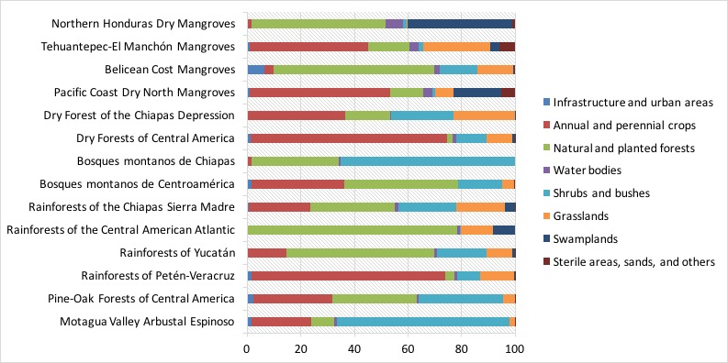

*Figure 3. Land use in Eco-regions of Guatemala (2003)*

The area with more agricultural activity in detriment of the forest cover is the Pacific Basin. There are 1.48 million hectares under cultivation. This is 61% of its surface area and almost half of all agricultural land in the country (49.4%). Its forest cover represents only 12% of its area. In contrast, the Gulf of Mexico Basin has a forest cover of 49% of its surface area (about 2.5 million hectares of forests).

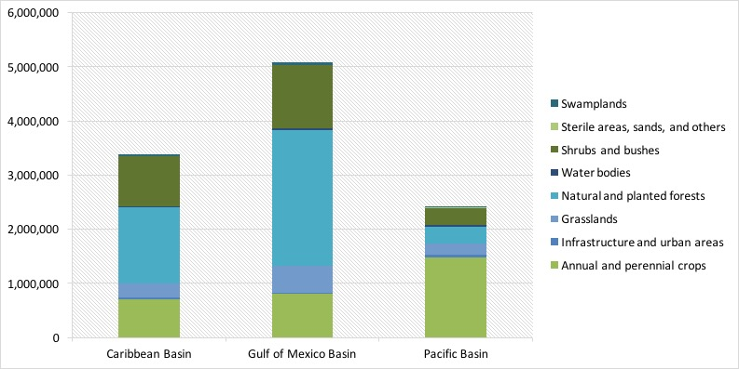

*Figure 4. Land use in Guatemala by Basin (2003)*

## How have forests changed?

In addition to understanding the current forest cover of a territory, it is illustrative to see how the forest has degraded over a certain period. In order to achieve this, we compare and contrast maps of forest cover built from satellite images. These maps require the work of several technicians from several institutions working together, and for this reason these maps are only published every few years. At the time of this comparison, only maps from 1991 and 2003 were available.

Guatemala lost 880,220 hectares of forest cover between 1991 and 2003, which represented a rate of deforestation of 17.3% for the analysis years, relative to the forest cover in the first year. The main affected areas were the Rainforests of Petén-Veracruz with 540,215 hectares of forest cover lost, and the Pine-Oak Forests of Central America with 192,628 hectares. These regions accounted for 82% of all deforestation in those years. However, the Dry Forests of Central America region saw a most alarming rate of deforestation of 44%. At that pace, forest cover in that region could not last more than 20 years.

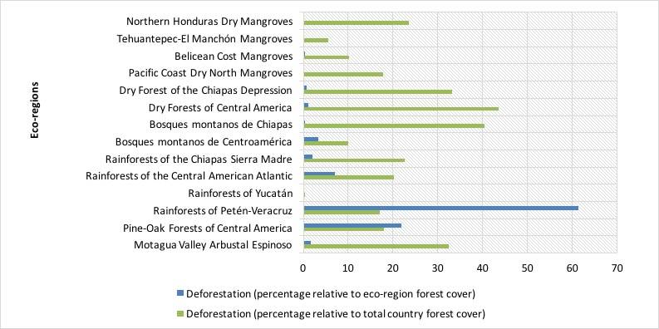

*Figure 5. Evolution of deforestation in Guatemala’s eco-regions between 1991 and 2003*

## Are these eco-regions capable of producing environmental services?

Evaluating the health of an ecosystem is a difficult task given the complexities of natural interactions. Nevertheless, there were indicators that we could use as proxies for ecosystem well-being. In that sense we evaluated forest density, forest fragmentation, and ecological integrity.

**Forest density** measures spatially the existence of forest cover in every square kilometer. The more dense a forest, the better its ecological integrity. The data showed that Guatemala’s more dense forests–especially those with densities higher than 60%–, lost relevant portions of forest cover. The Gulf of Mexico Basin shows the most losses, with reductions of over 20%. Those area categories with no forest cover and those with densities lower than 40% showed increases of over 20%.

**Forest fragmentation** measure the size of continuous blocks of forests and classifies them in 5 size categories. Between 1991 and 2001 four blocks of the larger categories (50,000 to 150,000 hectares) disappeared in the North of Guatemala, resulting in isolated areas of the 10,000 to 50,000 size category. In the South of the country, fragments were determined to be of the 0.5 to 2,000 hectare size predominantly.

**Ecological integrity** is a measure that we were able to infer from the two measures previously explained. This showed that nine out of fourteen eco-regions do not possess the minimum connectivity and fragment size required to guarantee the provision of environmental services.

The eco-regions with less than 10% forest cover showed the most ecological integrity problems, all of them located in the Pacific Basin. These were the Dry Forests of Central America, RaiRainforests of the Chiapas Sierra Madre and the Pacific Coast Dry North Mangroves.

[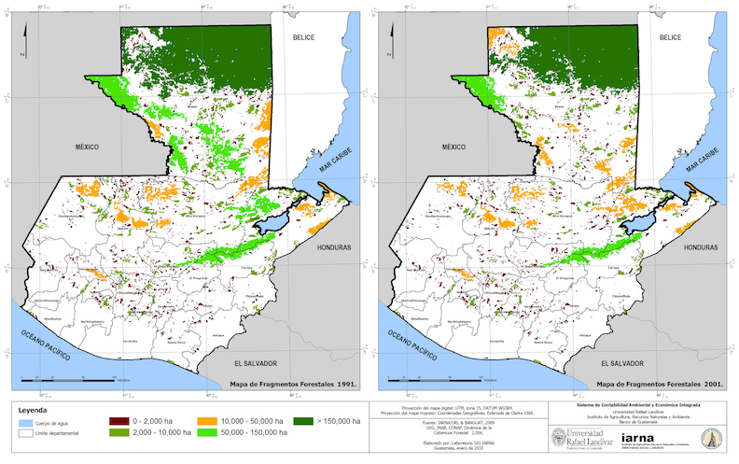](http://seeagt.github.io/float/ecosystems/ecosystems-map-fragments.jpg)

*Figure 6. Evolution of forest fragments between 1991 and 2001 (click to enlarge)*

There were, however, three regions with fragments large enough to guarantee a minimum ecological integrity, with a surface of 1.4 million hectares, equivalent to 13% of the country’s area. These were located in three eco-regions: Rainforest of Petén-Veracruz, Bosque Montano de Centroamérica, and Belicean Cost Mangroves.

[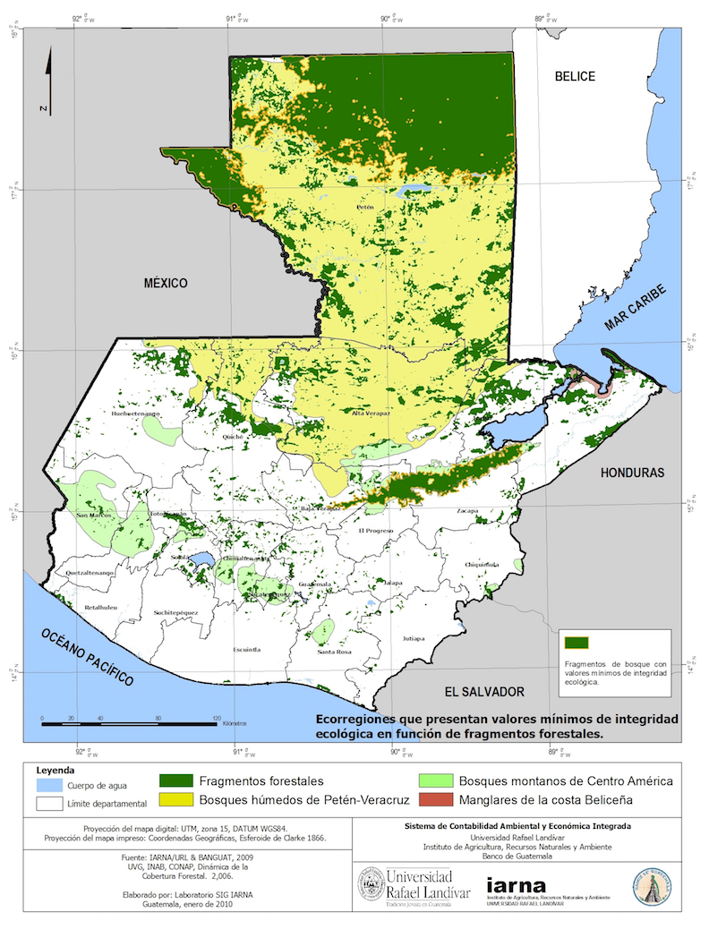](http://seeagt.github.io/float/ecosystems/ecosystems-map-integrity.jpg)

*Figure 7. Forest fragments with ecological integrity (2003)*

## What drives the changes?

A total of 73% of the 880,200 hectares that lost their forest cover between 1991 and 2003 became lands for agricultural uses. This is consistent with the transformation of 642,424 hectares of forest to annual and perennial crops (133,230 hectares), shrubs and bushes (289,133 hectares), and pastures (133,230 hectares). About 80% of forests from Arbustal espinoso del Valle del Motagua, Rainforests of the Chiapas Sierra Madre, Rainforests of Petén-Veracruz, and Dry Forests of Central America, changed to either crops, shrubs, bushes, or pastures.

## What are the economic costs of the degradation?

We evaluated the loss of two environmental services in order to determine effects of the degradation of forests. On the one hand we assessed the loss of the ability of forests to control erosion, and on the other we studied their capacity to store carbon. Our data showed that losses regarding these factors were equivalent to Q2,919.4 million (about $374.3 million) between 1991 and 2003.

Deforestation in the various regions resulted in the loss of 15 million tons of soil in the form of erosion, equivalent to Q1,150 million (about $147.4 million). We obtained these numbers from the loss of macro-nutrients (nitrogen, phosphor, and potassium) in every ton of eroded soil, depending to its category. Regions with the most losses were Rainforests of Petén-Veracruz (Q.733.5 million or $94 million), and Pine-Oak Forests of Central America (Q.237.3 million or $30.4 million).

As a consequence of the loss of forest cover, 368,622,243 tons of CO2 were released into the atmosphere, with at total cost of Q.1,769.4 million (about $226.8 million) at international carbon market prices. Of these losses, 85% can be attributed to the loss of forest cover in the Rainforests of Petén-Veracruz and the Pine-Oak Forests of Central America.

## Summary

In this essay we reviewed the findings of the land and ecosystems account of Guatemala. This account is a framework that determines the current status of the different eco-regions of Guatemala in physical terms and quantifies the rate of their use through an analysis of land use change and its effects on forest cover.

For analytical purposes, Guatemala was subdivided in 14 eco-regions. Five of these represent 90% of the entire area of the country, and the two largest are the Rainforests of Petén-Veracruz (44% of total area) and the Pine-Oak Forests of Central America (27%).

Three of these eco-regions had less than 20% forest cover and eight more than 50%. A total of 880,220 hectares of forest cover hectares were lost between 1991 and 2003. From 1991 to 2003 a total of 25% of forest cover was lost to both annual and perennial crops.

Out of 12 more representative regions, nine showed poor biophysical conditions of connectivity and minimum fragment size in order to guarantee their ecological integrity and the provision of natural goods and services.

There is a need to ensure the conservation of the four forest fragments, equivalent to 13% of Guatemala’s total area, which show minimum values of ecological integrity.

It is imperative to begin restoration efforts in the rest of eco-regions; especially in the Pacific Basin, where land use change have diminished its ecological integrity to the minimum.

Energy: Guatemala: a country that runs on fuelwood

*Natural capital accounting showed that Guatemala is a country whose main source of energy is fuelwood, and it also made clear that the production of electricity is the largest individual user of energy of all kinds, taking up to 3.3 units of energy in other forms to produce one unit of electricity.*

Table of Contents

Energy, the environment, and the Guatemalan economy in a nutshell 24

How does energy flow from the environment to the economy? 25

How does energy move within the economy? 25

What happens with Greenhouse Gas Emissions? 27

With what intensity is energy used by industries? 28

Summary 29

## Energy, the environment, and the Guatemalan economy in a nutshell

Nature provides the Guatemalan economy with coal, wind, power derived from water and thermal sources, fuelwood, sugar cane bagasse, and crude oil, among others. These are called “primary sources” of energy because they are usable in their natural form to some extent. We can take advantage of them locally or we can import them from the rest of the world. However, most of the economy’s productive processes cannot take advantage of these sources in their raw form, and so they are transformed into what we call secondary sources of energy. Examples of this type of energy include the various types of gasolines and diesel fuels, liquefied petroleum gas, and electricity.

Different industries, or economic activities, use both primary and secondary energy sources as inputs in their production processes. Households, in turn, use them to satisfy domestic needs like cooking, powering of devices, heating or cooling, among others. One special industry uses large amounts of various types of primary and secondary sources to produce electricity, which is then used universally by everyone else in the economy.

Finally, from the combustion—or simply burning—of some these energy products, industries emit various gases that go up into the atmosphere. Some of these are known as greenhouse gases and in our accounting efforts we have tracked carbon dioxide (CO2), nitrous oxide (N2O), and methane (CH4).

## How does energy flow from the environment to the economy?

Between 2001 and 2006, the Guatemalan economy used several types of energy resources directly from the environment in order to satisfy both the needs of industries and households. Water’s potential energy and thermal energy from volcanic activity were key resources in the production of electricity. The country also extracted crude oil and natural gas in some regions, which were destined almost exclusively for the export market. Guatemalans also imported coal from other countries mainly for the production of electricity. Nevertheless, in Guatemala the biggest source of energy obtained directly from the environment was biomass in the form of fuelwood for domestic use and sugarcane bagasse, mainly used as an input in the production of electricity.

The table below shows the relative structure of energy sources that were used directly from nature in Guatemala in terajoules (TJ) between 2001 and 2006. This is called primary energy. It is evident that biomass was extremely important for the country, with a use share of around 83% of all primary energy sources. And within that category fuelwood powered household activities with 224,227.3 TJ or 90% of that biomass. The second most important source of primary energy was coal, which was used mainly for the production of electricity and was mostly imported. Hydraulic and geothermal energy were also important for the country with around 20,534 TJ used in the year 2006. Even if oil production in the country was important as a source of foreign income, its direct use in Guatemala was minimal, with a share of about 1% of primary resources.

***Table 1. Primary energy (terajoules)***

|  |  |  |
| --- | --- | --- |
| Primary energy | terajoules | percentage (%) |
| Biomass (100%) | 248,313.70 | 82.5 |
| -Of which, fuelwood (90.3%) | 224,227.30 |  |
| -Of which, bagasse (9.7%) | 24,086.40 |  |
| Hydraulic and geothermal energy | 20,533.90 | 6.8 |
| Oil and natural gas | 1,705.60 | 0.6 |
| Coal | 30,503.80 | 10.1 |
| Total | 301,057.00 | 100 |

Source: Iarna/Banguat (2009)

## How does energy move within the economy?

A total of 483,947.3 TJ[1](index.html#fn:3cc96d9b80e0f953d1c554f50c09bdb0:8) of energy in all its forms was available to the Guatemalan economy in 2006. That energy was used as inputs in the production of goods and services by several industries, and also by households, the government, and non-profit institutions in processes such as cooking, artificial lighting, heating, or cooling.

The figure shows quantities of energy in terajoules used by the different economic industries and households in the rows, coming from the various energy sources in the columns. Darker tones represent higher uses of energy relative to total consumption. According to this, household final consumption of represented around 47% of total use and even surpassed slightly all consumption of energy used as inputs in production processes (46%). This was due not only to the fact that households were the main users of fuelwood (which has a high calorific content), but also of gasoline, liquefied petroleum gas for cooking, and electricity.

[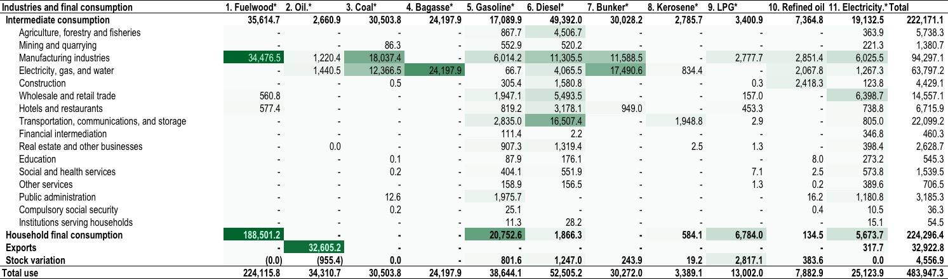](../../float/energy/energy-heatmap.jpg)  
*Figure 1. Energy use heatmap 2006 (terajoules) (click to enlarge)*

The largest user of energy of all types in the Guatemalan economy was by far the production and distribution of electricity with a total of 61,594 TJ, equivalent to 27% of the energy used by industries as inputs in 2006. This meant that the Guatemalan society used a large percentage of energy of different kinds (such as coal, bunker, diesel, bagasse, etc.), which in many cases was imported at high costs, to produce electricity.

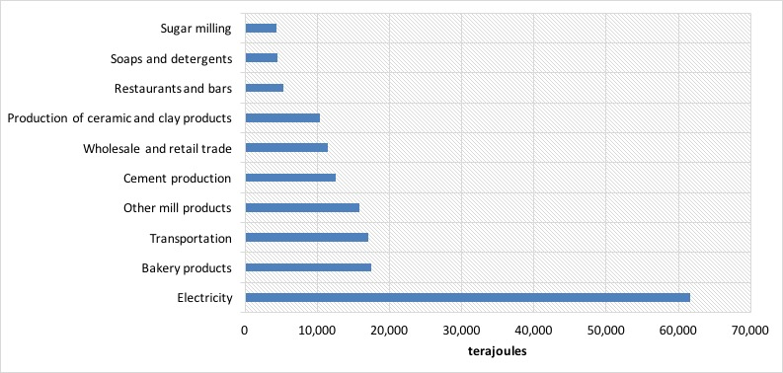

*Figure 2. Largest users of energy, 2006 (terajoules)*

## What happens with Greenhouse Gas Emissions?

The total human contribution to greenhouse gas emissions from the combustion of different energy sources in Guatemala amounted to 45.6 million carbon dioxide metric tons equivalent in 2006. In general terms, that was less than 1% of total world emissions. Nevertheless, since it is such an important topic in general terms, it could still carry financial consequences or opportunities regarding international treaties on the matter and we need to track its performance. Table 11 shows the distribution of emissions among groups of economic industries.

The figure below shows the greenhouse gas emissions of the top five emitting industries on the left of the vertical axis with bars and those of households on the right of the vertical axis with a line. Households emissions were considerably higher, due to the high carbon content of fuelwood and their large use of that product, coupled with their considerable use of gasoline. Among the top emitters, it is interesting to note that the emissions of the production and distribution of electricity more than doubled those of the industry that follows it. This was consistent with the high use of fossil fuels in the production of electricity.

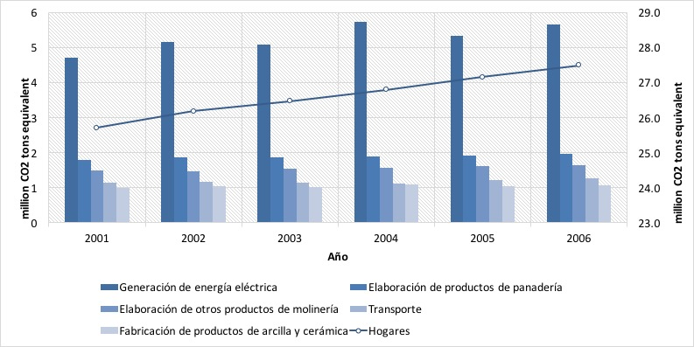

*Figure 3. Selected greenhouse gas emitters, 2006 (CO2 tons equivalent)*

The second industry on the graph is the production of bread which is there because of its high use of fuelwood. In a GHG inventory (those advocated by the Inter Governmental Panel on Climate Change) emissions from biomass do not count toward the total emissions and are left as “memorandum items”, this in order to avoid double counting. In the supply and use accounting structure of the SEEA, this is not a problem, and hence they were included. If fuelwood and bagasse were excluded, bakeries and mills would exit this list and cement production and retail trade would replace them. Finally, due to its high use of different fuels, the transportation industry was also important in this context.

## With what intensity is energy used by industries?

Figure 5 shows an indicator called energy intensity for six economic industries for 2001-2006. Due to the nature of each type of economic activity, we can find these at different general levels of intensity. Some industries needed less energy to produce one unit of wealth added to the economy in that year (value added), like retail trade for example, and others, like cement production needed considerably more. For that reason it is not altogether adequate to compare intensities between industries. However, it is possible to compare how a specific industry fares through time. In that way, we can see if use of energy per unit of newly added wealth has improved or become worse.

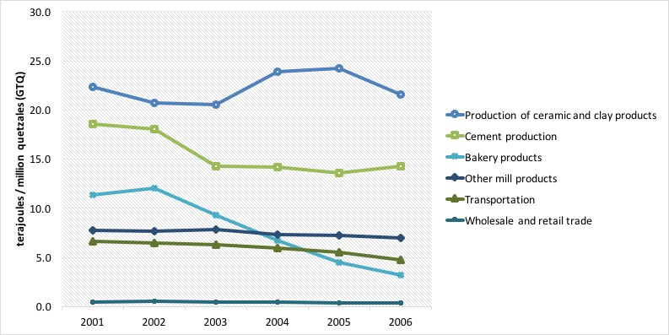

*Figure 4. Energy intensity for selected industries*

In the case of Guatemala, the production of bread showed a decrease in its intensity in the period. The production of ceramics showed a more erratic behavior, but mantained its high level of energy use, whereas transportation and general mills had a more stable energy intensity over time. This is probably due to the fact that technology is replaced less often in those activities.

## Summary

In this essay, we have introduced the Energy and Emissions Account of Guatemala. This account is a framework that allows us to understand the intricate relationship between the environment and the economy in terms of energy resources, and at the same time quantify the emissions that result from the combustion of the different types of energy.

In the last year of the analysis, there was an energy consumption of 483,947 terajoules.

Around 46% of all the energy consumed can be attributed to household final use, where fuelwood, gasoline, and electricity are predominant.

The production of electricity used about 13% of all energy consumption, equivalent to 61,594 TJ.

Among the relevant players in the consumption of energy we found the production of bakery products (3.6% of total use), transportation (3.5%), grain milling (3.3%), cement production (2.6%), wholesale and retail trade (2.2%), restaurants and bars (1.1%), sugar milling (1%), and the production of soaps and detergents (1%).

From the combustion of energy, a total of 45.6 million CO2 tons equivalent were emitted to the atmosphere, of which the 5 largest emitters (excluding households) were responsible for 11.6 million CO2 tons equivalent or 64%. Households emitted around 27.5 million CO2 tons equivalent.

In terms of intensity, a measure that compares energy use with value added generation, we have that the electricity generation industry requires 14.2 terajoules for every million quetzales (GTQ) that it contributes to GDP, which contrasts with the average for manufactures (2.9 TJ for every million GTQ), or trade activities that circle below 1 TJ for every million GTQ of value added.

Fisheries and aquaculture: Environmental and economic accounting for fisheries

*The total contribution of fish farming and aquaculture to GDP oscillated between 0.19% and 0.25% between 2001 and 2005, which is notably low in the Guatemalan economy.*

Table of Contents

What is environmental and economic accounting for fisheries? 31

What are some general trends regarding fish stocks? 31

What happens with fishing? 32

What about aquaculture? 34

What are the economic benefits of fish farming? 37

What impacts do these industries cause? 40

Summary 41

## What is environmental and economic accounting for fisheries?

The fisheries account of Guatemala is a framework that provides information on the link between fish stocks, both cultivated and not cultivated, and the economy. This work looked at data from the year 2001 through 2005. It links information on economic transactions and integrates it with the physical information on fish availabilities. In particular fisheries accounting:

* Records fish stock inventories.
* Records flows of fish availabilities between the environment and the economy.
* Records expenditures destined for the protection of fish resources.
* Provides a set of indicators that track the performance of fish activities.

## What are some general trends regarding fish stocks?

Fish production in Guatemala is of an extractive nature, according to the data. In the accounting years, ocean and continental captures represented between 73% and 87% from the total supply of fish, leaving the remaining 13% to 27% to aquaculture, i.e. fish farming. The most relevant fluctuation happened in captures in the Pacific, which went from 26,459 metric tons in 2001 to 4,854 in 2005. There was an over all downward trend in output during the analysis years, with a significant drop in production to almost half from 2003 to 2004, with a slight recuperation in 2005 that is expected to continue.

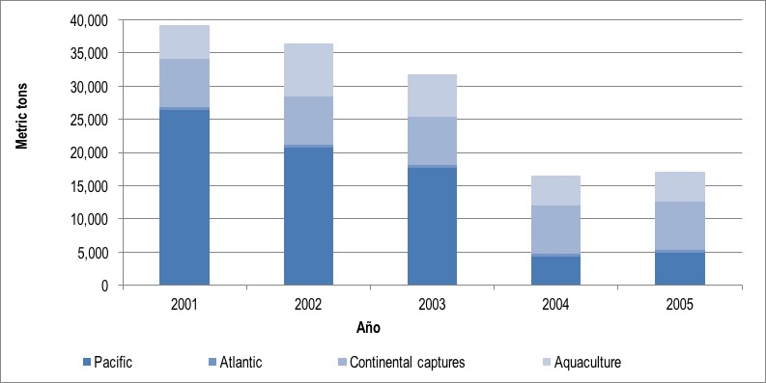

*Figure 1. Total output from fisheries and aquaculture, 2001-2005 (metric tons)*

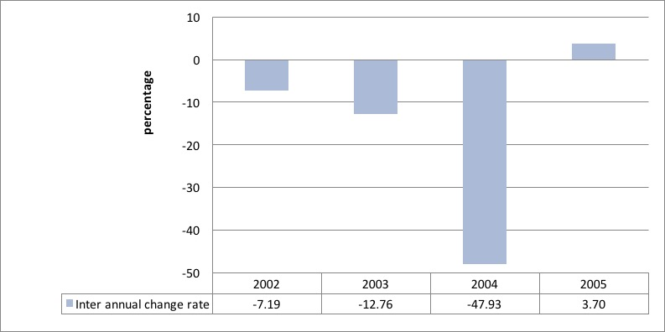

*Figure 2. Inter annual change in output from fisheries and aquaculture, 2002-2005 (rate of change)*

## What happens with fishing?

Geographically, fishing takes place in the Pacific coast, the Atlantic coast, and continental waters. We term the first two “marine fishing.” In terms of output, marine activities have been the most intense, mainly in the Pacific. As we saw earlier, there was a relevant drop, related to a drop in tuna extraction, which went from 23,528 metric tons in 2001 to 3,353 in 2005; an 85% drop. In turn, Atlantic coast fishing and continental fishing remained stable with annual extractions between 345 and 485 metric tons in the first case, and of 7,300 metric tons in the second case.

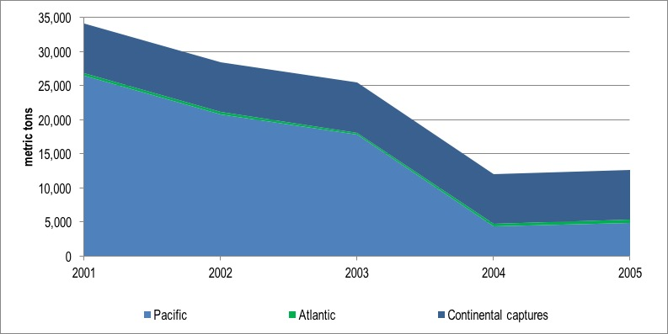

*Figure 3. Fisheries output by geographic area, 2001-2005 (metric tons)*

Pacific coast fishing is dominated by tuna fish and shrimp extraction to the point that these two species have reached 94% of all output in 2002. However, there have been other species that were captured as well. For example, from in 2004-05 there was a spike in the production of demersals, sharks, rays, and chimeras.

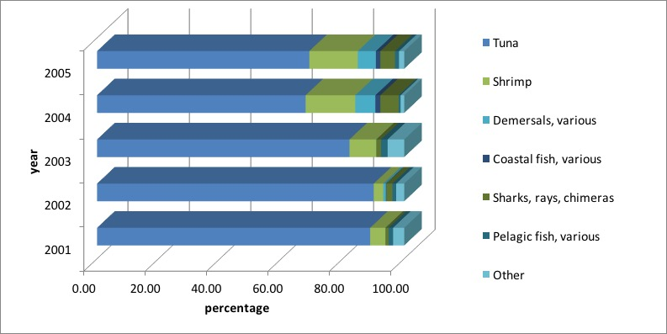

*Figure 4. Captures in the Pacific coast by species, 2001-2005 (percentage from total production)*

## What about aquaculture?

In some Central American countries, like Belice and Honduras, aquaculture or fish farming represents upwards of 80% of the entire fish output. This is not the case in Guatemala, where fish farming contributed between 13% and 27% of annual output in the years 2001-2005. From this industry, fresh water shrimp (between 49% and 87% of their output) and tilapias (between 13% and 47% of total output) were most relevant.

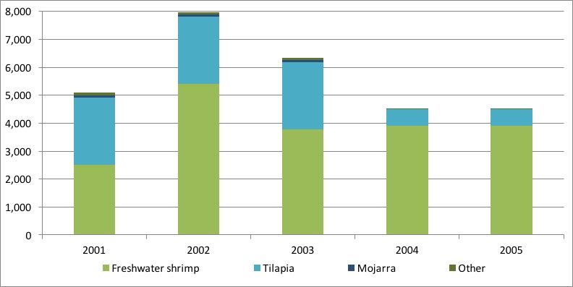

*Figure 5. Aquaculture by species, 2001-2005 (metric tons)*

Data reveals that fish farming occurs in most departments (largest administrative geographical area) of Guatemala. Nevertheless, it is in Escuintla that most surface area is devoted to this industry, with about 324 hectares, or 73% of the entire country’s aquaculture land. Retalhuleu is also relevant with a share of 9%, and Jalapa and Suchitepéquez with 4% and 3%, respectively. The rest of the country takes up the remaining 11%.

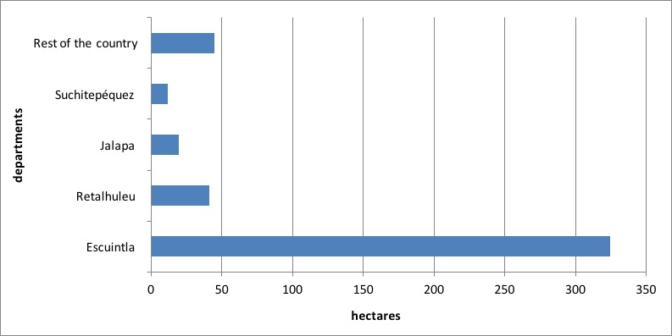

*Figure 6. Surface area devoted to fish farming by department, 2003 (hectares)*

Shrimp is a product that is mainly produced in the departments adjacent to the Pacific coast. A relevant 99% of the surface area destined to this type of production concentrates in Escuintla, Retalhuleu, and Suchitepéquez. The remaining 1% is spread over the rest of the departments. Fish farming is more evenly distributed, with 33% of the surface in the East (Jalapa and Jutiapa), 29% in the South (Escuintla, Santa Rosa, and Suchitepéquez), 9% in Izabal to the Northeast, and 29% in the rest of departments.

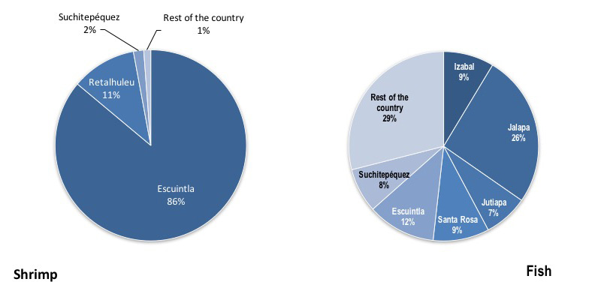

*Figure 7. Distribution of surface area destined to shrimp and fish farming in Guatemala, 2003 (percentage)*

## What are the economic benefits of fish farming?

In monetary terms, fisheries and aquaculture contribution to the economy had a downward trend. The drop in physical volumes observed in the analysis years was dampened in monetary terms due to an increase in the price of products from these industries. In 2001, output from fisheries and aquaculture was valued at GTQ 894.4 million, while in 2005 this reached GTQ 740 million, equivalent to an 18% reduction. In those same years there was a drop in output of 66%. In other words, a metric ton of output was valued at GTQ 22,907 in 2001, and at GTQ 43,174 in 2005.

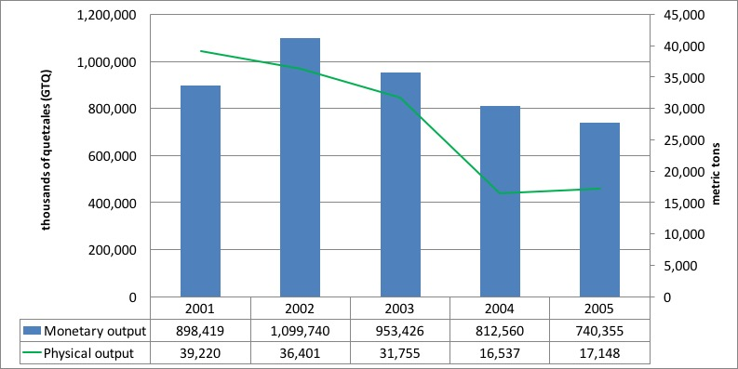

*Figure 8. Total output from fisheries and aquaculture (metric tons and thousands of quetzales—GTQ)*

The total contribution of fish farming and aquaculture to GDP oscillated between 0.19% and 0.25% between 2001 and 2005, which is notably low in the Guatemalan economy. The industries linked to fisheries and aquaculture generated value added in the order of GTQ 289 million in 2001 and GTQ 418 million in 2004.

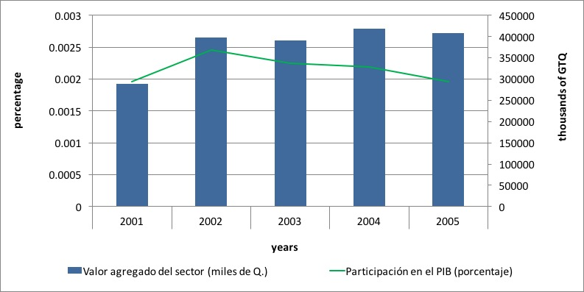

*Figure 9. Value added and contribution to GDP from fisheries and aquaculture, 2001-2005 (percentages)*

In terms of use of products from these industries, evidently households took up the largest share, which represented 54% in 2005. Exports were responsible for 22% of total use, and the food processing industries used 17% as inputs for their production. The remaining 7% became stock variation.

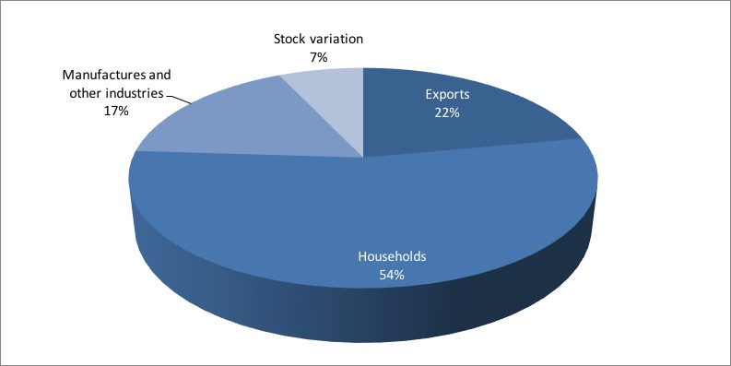

*Figure 10. Use of products from fisheries and aquaculture, 2005 (percentages)*

## What impacts do these industries cause?

Those animals that are caught alongside the target species are usually discarded back into the oceans. This is added to the fraction of the target species that is also discarded for economic or other reasons. The volume of discarded material depends in the different fishing gears. In the case of Guatemala, shrimp and tuna captures were responsible for between 3,387 and 8,924 metric tons of discards in the years 2001-2005. Of the total discarded volume, these values represented between 79% and 95% in the analysis years.

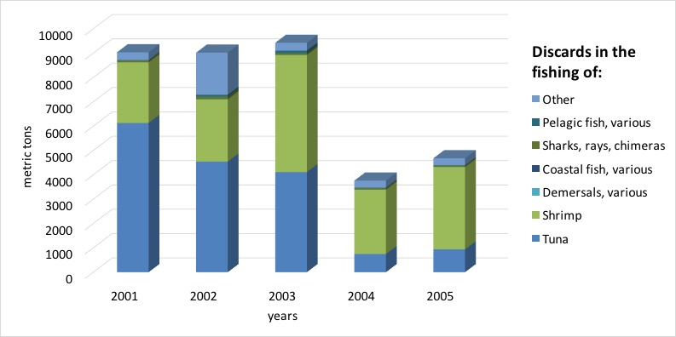

*Figure 11. Discards of marine fishing, 2001-2005 (metric tons)*

## Summary

In this essay we presented the fisheries and aquaculture account of Guatemala as a framework that provides information on the link between fish stocks, both cultivated and not cultivated, and the economy. It is interesting to note that:

* From 441 hectare that were devoted to fish farming in Guatemala in 2003, 83% produced shrimp. The rest was used for fish farming of mainly tilapia (16.9%), and molluscs (0.1%).
* In the years 2001-2005, between 90% and 98.5% of total marine captures were made in the Pacific, with the remainder in the Atlantic; 4,854 metric tons were captured in the Pacific out of 5,340 metric tons captured in total.
* However, total captures in the Pacific saw a relevant drop in the analysis period going from 26,460 metric tons in 2001 to 4,854 metric tons in 2005; an 82% reduction.
* Tuna and shrimp are the main species captured in the Pacific. A total of 3,353 metric tons of tuna fish and 766 of shrimp were captured in 2005.
* The Atlantic represented about 9% of total captures in 2005; 487 metric tons.
* Shrimp is the most relevant species in the Atlantic, with between 47% and 78% of total extraction in the analysis years.
* Continental captures remained stable at about 7,300 metric tons annually between 2001 and 2005.
* Aquaculture produced between 4,508 and 7,978 metric tons annually of mainly shrimp, tilapia and mojarra.
* Total output from fisheries and aquaculture saw an important reduction from 39,220 metric tons in 2001 to 17,148 metric tons in 2005, owing specifically to the drop in production in the Pacific.
* In the best year of the analysis period, these industries outputted GTQ 1,100 million to the Guatemalan economy.
* The value added from these industries was modest, contributing between GTQ 288 million in 2001 and GTQ 418 million in 2004 to GDP.
* Regarding environmental impacts, marine captures were responsible for discards of between 3,762 and 9,425 metric tons annually between 2001 and 2005. This represents between 26 and 37 metric tons of discarded animals for every 100 metric tons of target species. The capture of shrimp and tuna were most relevant in this sense.

Forests: Tracking the economic causes of deforestation

*Forest accounting revealed that over 95% of deforestation happened outside of the control of government institutions and that the use of fuelwood has a higher impact on forests than previously thought.*

Table of Contents

What is a forest account? 43

What’s the status of forests in Guatemala? 43

What is the monetary value of the Guatemalan forests? 45

How are forest products used in the economy? 47

What is the impact of depreciation of forests on economic measures? 50

Final remarks 52

## What is a forest account?

The forest account of Guatemala is a framework that explains the relationship between forests and the economy. It puts together information on the status of forests and economic transactions associated with them in a systematic manner. It reveals the real contribution of forests to the national economy and the possible impacts that the economy might have on the well-being of forests.

More specifically forest accounting measures the stocks of the national forest inventory and the flows associated with it; it identifies the industries and stakeholders that benefit directly or indirectly from forests; it records expenditures made by government institutions in order to mitigate damages to and restore the well-being of forests; and extend macro-economic aggregates and indicators in order to reflect the depreciation of the forest resources.

## What’s the status of forests in Guatemala?

In order to answer this question we turn to the change of forest land stock in comparison with 1970 and to an indicator of this change relative to population (forest land stock per capita). As for changes in land stock, by 2005 Guatemala had lost close to 40% of its 1970 availability. More illustrative is the fact that due to high population growth rates, availability of forests per capita have dropped in a relevant way.

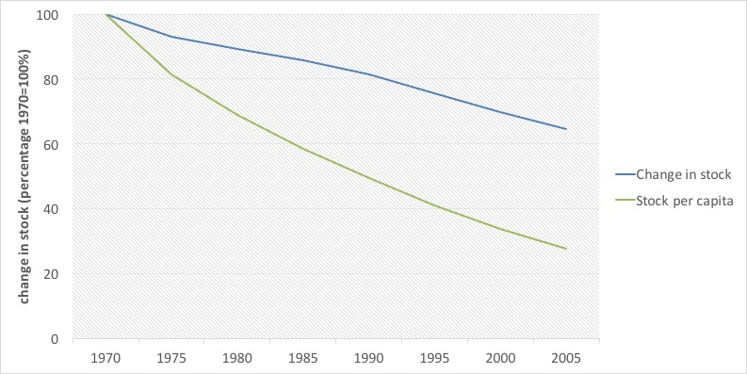

*Figure 1. Land stock change from 1970 to 2005 (percentages, 1970=100)*

Another important indicator is the rate of deforestation, which helps to measure the impacts of government policies on sustainable resource use. In the case of Guatemala, absolute deforestation rates are stable between 60,000 and 70,000 hectares per year. This represents an annual stock loss of about 1.5% per year. The highest since 1950, and even greater than 1970s records, when population reallocation policies pushed for aggressive changes of forest land into agricultural land. That rate seems high when put in context with others from Latin America from the 1990-2000 decade, such as Brazil (0.4%), Bolivia (0.3%), Colombia (0.4%), Ecuador (1.2%), and Mexico (1.4%).

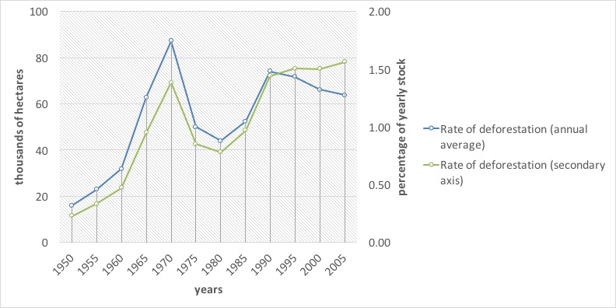

*Figure 2. Deforestation rates 1950-2005 (thousands of hectares and percentages of stock relative to the previous year)*

There are other causes of reduction of forest volume, such as timber and fuelwood selective extraction, de-branching, forest fires, plagues and diseases, as well as natural mortality. Uncontrolled logging and selective fuelwood extraction is one of the main reasons for forest volume reduction. By forest account estimates more than 95% of forest product flows in the country (30.7 million m3) happen outside the control of the forest government authorities (National Institute of Forests—INAB—and the National Council for Protected Areas—CONAP—). Forest accounting estimates attribute 76% of that uncontrolled forest use to fuelwood extraction and 24% to timber extraction. Up to two thirds of all timber processed by wood processing industries is estimated to come from uncontrolled sources.

The rise uncontrolled traffic of forest products is consistent with (i) a lack of institutional capabilities for control, (ii) an ineffective control system for the transportation of forest products, (iii) the lack of an effective transportation permit issuing system, (iv) obscure market practices that operate under the legal umbrella of family forest allowances, and (v) a lack of raw materials origin control within the wood processing industries.

## What is the monetary value of the Guatemalan forests?

The forest account assigned market valuations to standing timber between 2001-2006. In that period the value of forests went from 56,351.9 million quetzales (GTQ) to 83,467 million. This is a behavior more consistent with non-renewables than with renewable resources and hints that forests might be used unsustainably. Under sustainable practices, forest regeneration should provide constant availability at stable prices.

Even when valuating at constant prices of 2001, monetary values of forests increased in spite of the reduction of the forest stock, which was close to 76 million m3 between 2001 and 2006.

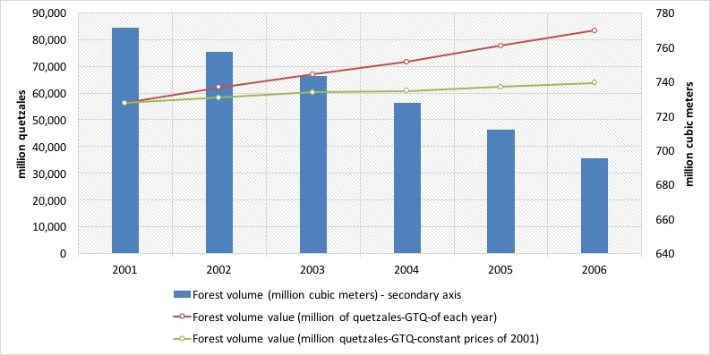

*Figure 3. Forest volume and monetary value of forest assets for the years 2001-2006 (cubic meters and valuation at constant prices of 2001)*

If we contrast forest growth with reduction due to either controlled or uncontrolled logging, it is easy to see that the former does not compensate for the latter. In 2006, for example, that resulted in the loss (or net stock variation) of GTQ2,076 million. On the other hand, uncontrolled logging represented more than GTQ2 billion, which exceeds the value of controlled logging by far.

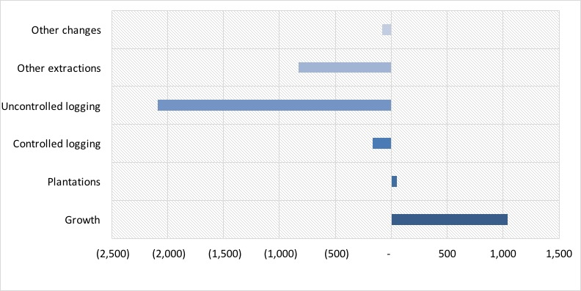

*Figure 4. Forest stock variation in monetary terms for the year 2006 (million GTQ)*

## How are forest products used in the economy?

In terms of volume, households are the largest users of forest products, using 22.6 million m3, which represented about 67% of total national consumption. Most of that use (92%) corresponded to fuelwood use. The remainder is mostly used by the saw mill industry and the production of furniture.

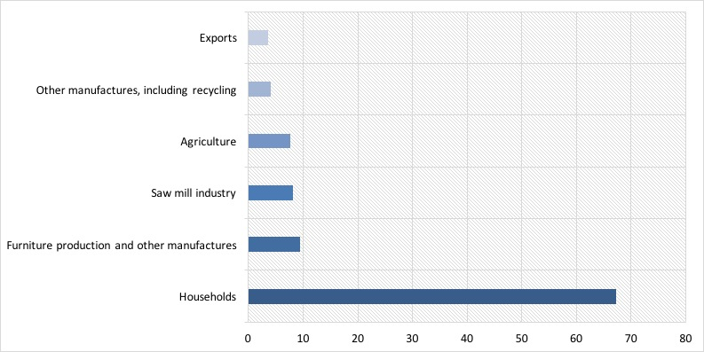

*Figure 5. Main users of forest goods in Guatemala in 2006 (percentages)*

On the other hand we have total supply of forest products in monetary terms. Primary output contributes 34% of total supply of wood products, with a strong component of logging products and fuelwood.

Historically, non-wood products have contributed less to total supply and in 2006 they represented about a billion GTQ. In spite of the touted idea that non-wood products represent a high potential, in Guatemala this market is still small.

Secondary output, consisting of sawn wood and furniture is responsible for the largest numbers in total supply. In 2006, their value reached GTQ 8.2 billion, corresponding to a little over 40% of total supply of forest products.

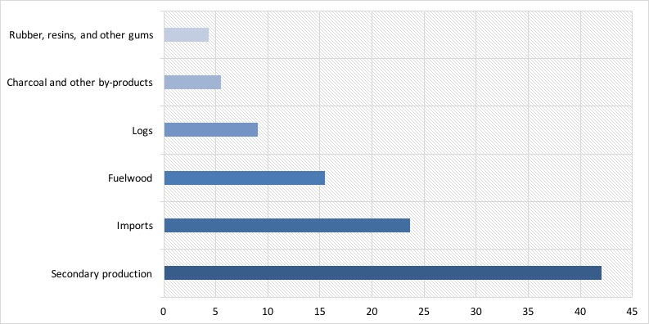

*Figure 6. Supply of forest products in 2006 (percentages)*

Demand of primary output of forest products (wood products, non-wood products, wild animals and their products) is linked to final household consumption. Intermediate consumption or that used as inputs by other industries, represents about 40%, and exports 12% of total use. These numbers are highly influenced by the use of fuelwood as a source of energy and by a small forest industry with little incidence in exports.

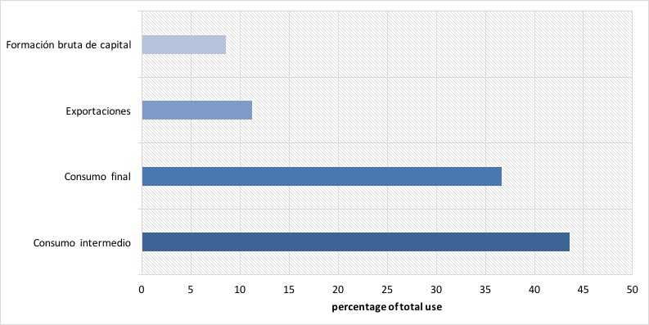

*Figure 7. Demand of forest products in 2006 (percentages of total use at purchaser prices)*

## What is the impact of depreciation of forests on economic measures?

One important finding of the forest account is that the real contribution of forest products to the national economy circles around 3.15% and 2.57% for the years 2001 and 2006, respectively; while normal GDP measures attribute only contributions of 1.02% and 0.93% in the same years, respectively.

Another important finding is that the value of resource exhaustion (or its depreciation) is equivalent to 0.9% of GDP for the year 2006. What this implies is that if we take into account the forestry sector by itself, total contribution to the economy would be zero in practical terms.

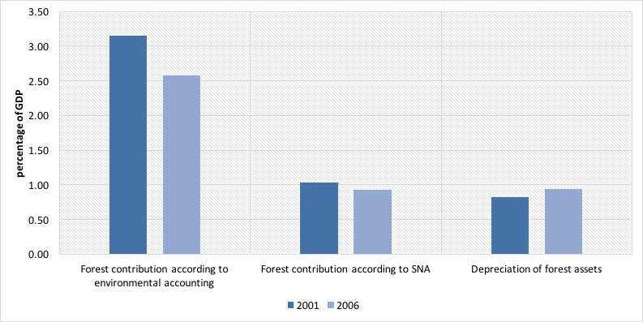

*Figure 8. Contribution of forests to the economy in 2001 and 2006 (percentages)*

When adjusting GDP for the depreciation of forests, we see only a small reduction of about 1%, which is evidence of a small over-estimation of the true performance of the economy. This could be larger if unsustainable use of other natural resources were included in this calculation.

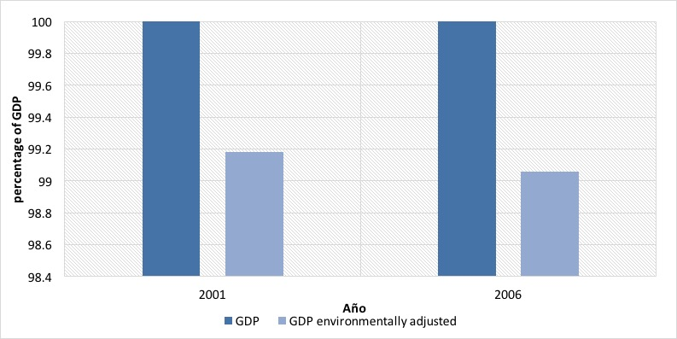

*Figure 9. GDP adjusted for the depreciation of forests in 2001 and 2006 (percentages)*

When comparing the direct value of depreciation of forests with public investments which are destined to the protection and regeneration of forests it is evident that they are insufficient to cover the depreciation that we discussed earlier; i.e. the Budget of the National Institute of Forests—INAB—, including the National Forest Incentives Program, and the National Council for Protected Areas—CONAP—. Forest management expenditures (current and capital expenditure) represent only about 10% of the depreciation.

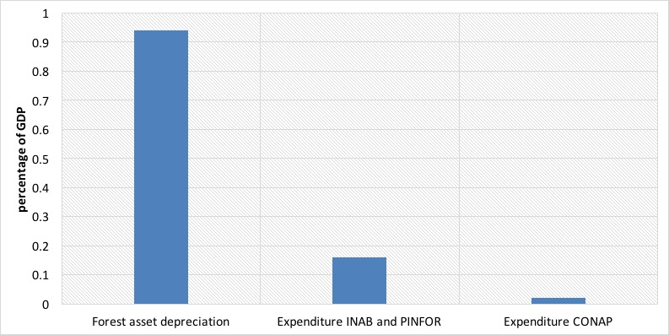

*Figure 10. Comparison between depreciation of forest resources and forest protection expenditure in 2006 (percentages)*

## Final remarks

We have introduced the forest account of Guatemala; a framework that explains the relationship between forests and the economy, bringing together information in order to reveal the real contribution of forests to the national economy and the possible impacts that the economy might have on the well-being of forests. Some of the most important findings include:

* In 2006, Guatemala had 5,694,561 hectares of forest land, including natural forests, forest plantations, forest land, and shrubs. This is equivalent to 52.3% of the national territory and to 66.3% of total forests in 1950.
* When contrasting with population growth, available forest land in 2006 represented 0.43 hectares per inhabitant, a mere 16% of that same indicator in 1950.
* Of the 4,015,749 hectares of natural forests in 2006, 55% are located inside protected areas. The rate of deforestation of these forests is of about 1.6% annually, which represents a net loss of 73,000 hectrares per year. Over 28,000 hectares were lost inside protected areas.
* In 2006 the total forest volume was 695281.7 million m3, valued at GTQ83.5 billion at current prices.
* Logging represented 29,168,397 m3 and other losses 1,543.6 million m3. Of this last group, forest fires were the most important and represented a loss of 1.32 million m3 in 2006.
* The economy used a total of 33.6 million m3 of forest products in 2006. A total of 67.3% of these flows were used by households, 9.36% were used for the production of furniture and other wood products, 7.63% by agricultural industries, 3.55% became exports and 4.05% was reused by the recycling industry.
* Forest accounting estimates in 2006 place the flows of forest products at a value of GTQ14,980.4 million, of which 35.5% correspond to wood products, 7.81% to non-wood products, 0.15% to wild animals, and 0.07% to tourism services. The remaining 55.*% corresponds to the wood processing industries. Wood waste was valued at 0.21% of total wood flows.
* Of total forest product flows, 53% was used by final consumption, 35% was used as inputs by other industries, and 12% became exports.
* Environmental protection expenditures for forests reached GTQ276.4 million, which is equivalent to only 12.82% of what is required to restore forests.

Subsoil: Valuing what lies beneath the surface

*The industries related to subsoil resources contributed between 1.94% and 2.34% of GDP annually in the analyzed years, specially owing to the non-metallic minerals extraction industry. Conversely, oil extraction was the largest use of these resources in physical terms.*

Table of Contents

What is Subsoil Resources Accounting? 54

What are the general trends regarding the extraction of subsoil resources? 54

How are subsoil resources used? 58

And which industries use the most subsoil resources? 59

How valuable are subsoil resources? 59

What are the economic benefits of extracting subsoil resources? 61

Summary 61

## What is Subsoil Resources Accounting?

The subsoil resources account of Guatemala is a framework that provides information on the availability of stocks of these resources and how they are used by the economy. It links information on economic transactions and integrates it with the physical information on subsoil resource flows. In particular subsoil resources accounting:

1. Takes inventory of subsoil resources in the country. Specifically, of metallic minerals, non-metallic minerals, and hydrocarbons.
2. Accounts for flows of subsoil resources between the environment, the economy, and the various stakeholders in the economy.
3. Quantifies expenditures made in order to mitigate and prevent impacts generated by the extraction of subsoil resources.
4. Provides a set of indicators in order to evaluate the environmental and economic performance of all these relationships.

## What are the general trends regarding the extraction of subsoil resources?

Between 2001 and 2006, the Guatemalan economy extracted 284 million metric tons of subsoil assets from the ground, of which 54% (152 million metric tons) were hydrocarbons. About 45% of the total was non-metallic minerals, which are used mainly by the construction industry and some manufacturing processes. The remaining 1% corresponded roughly to metallic minerals.

Midway during the analysis period both hydrocarbon and non-metallic mineral extraction changed their growing trend and started a contraction phase. This happened after 2003 in the first case, and from 2004 onwards for the second. By 2006 hydrocarbon extraction represented about 65% of the highest level it had reached three years earlier. Non-metallic minerals saw a 29% reduction, in comparison to the levels of 2003. Metallic minerals showed no defined tendency.

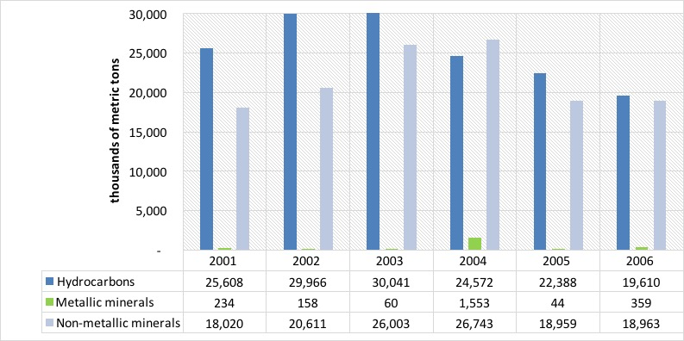

*Figure 1. Subsoil resource extraction by type of asset (metric tons)*

Subsoil resources stocks vary negatively as a result from extraction and positively when new discoveries are made. In the case of Guatemala, extractions usually surpass new discoveries so we can see a general downward trend of these stocks. Hydrocarbons, for example, saw a 5% reduction in their availability as a result of extraction, going from 2,861 million metric tons in 2001 to 2,729 in 2006. Non-metallic and metallic minerals saw a 1% reduction by 2006, compared to their stocks in 2001.

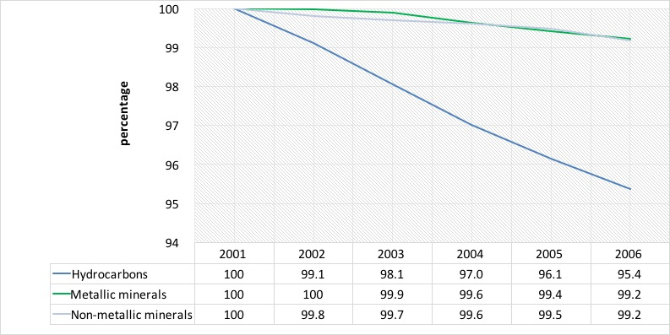

*Figure 2. Yearly opening stocks of subsoil resources (percentages 2001= 100%)*

The supply of subsoil resources is overwhelmingly dominated by hydrocarbons and non-metallic minerals in comparison with metallic minerals. In the case of hydrocarbons, total supply varied between 19,623 and 30,856 thousands of metric tons annually between 2001 and 2006. This was equivalent to 42% and 59% of total supply, respectively. Non-metallic minerals shows a similar performance. In some years, the supply of these minerals has surpassed that of hydrocarbons, reaching 50% of total subsoil resources supply. Physical supply of metallic minerals has been considerably lower to that of the other two groups. In our analysis years, its relative importance oscillated between 0.2% and 5.8% of total supply.

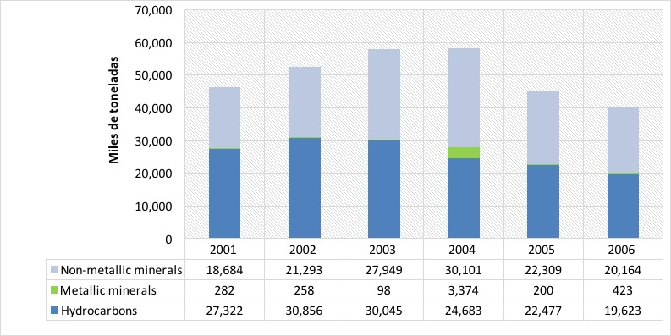

*Figure 3. Physical supply of subsoil resources (thousands of metric tons)*

Total supply has a locally produced component and an imported one. For hydrocarbons and non-metallic minerals the imported portion is not relevant. However, in the case of metallic minerals, imports reached as much as 78% of total supply in 2005 and 48% in the entire period. In contrast, hydrocarbons and non-metallic minerals imported 2% and 8% of total supply from 2001 to 2006, respectively.

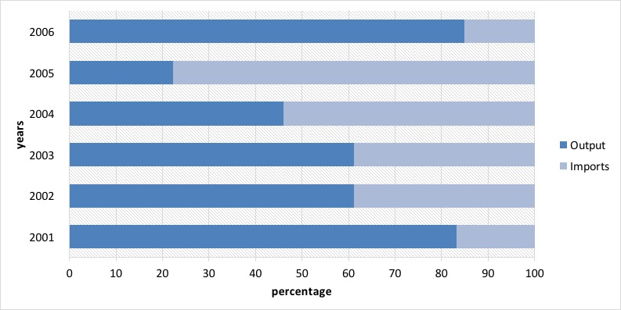

*Figure 4. Output vs import of metallic minerals, 2001-2006 (thousands of metric tons)*

## How are subsoil resources used?

Subsoil resources are mostly used as inputs in industrial processes, both from local companies, as well as from abroad. Households consumed between 217 and 354 thousands of metric tons annually in our analysis years. That was equivalent to less than 1% of total supply in any year, which consists of up to 99% of resources for construction processes, such as limestone. In contrast, their use as exports and as inputs in other industries, which we term “intermediate consumption”, reached between 73% and 84% of total use in the analysis period.

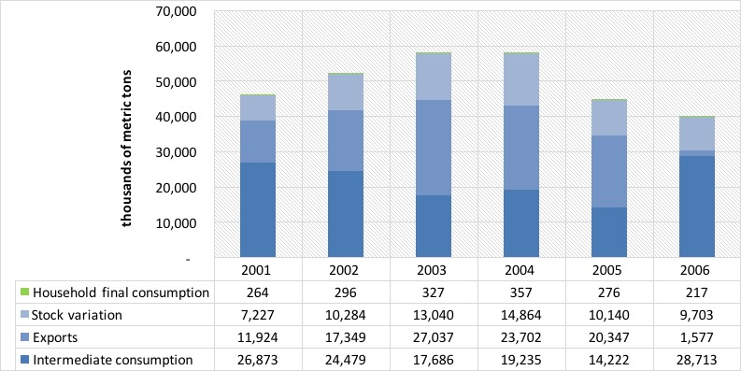

*Figure 5. Subsoil resource use between 2001 and 2006 (thousands of metric tons)*

## And which industries use the most subsoil resources?

When we analyze the above mentioned intermediate consumption, or the use of products as inputs in production processes of other industries, it is possible to dig deeper and disaggregate the industries that are the largest users of these resources. In the case of these products, there are six industries out of the 123 identified in the Guatemalan economy that represent 93% of total demand. The remaining industries used about 9 million metric tons of subsoil resources, or about 8% of total intermediate consumption. We group the most important six in three groups:

1. Oil refinement, which process oil into different types of fuels. This group is responsible for 46% of total intermediate consumption in our analysis years, using about 61 million metric tons of hydrocarbons.
2. Industries related to construction, such as construction itself, cement production, prefabricated concrete products, and structural ceramic products. These industries used about 55 million metric tons, or about 42% of total intermediate consumption in the entire analysis period.
3. The production of electricity used about 4% of intermediate consumption.

## How valuable are subsoil resources?

We analyze the value of subsoil resources from the perspective of the valuation of their stocks. When comparing opening stocks, we see a 134 million metric tons reduction from 2001 to 2006, or about 4% of the total. The biggest reduction occurred in hydrocarbons. But the value of that stock might change because of market circumstances and it might fluctuate even if physical stocks remain the same. We see one such revaluation of Guatemala’s stocks in the accounting period.

In the case of hydrocarbons, for example, the opening stock valuation rose from 179,679 million quetzales (GTQ) in 2001 to GTQ 491,336 million, in spite of stock reductions and not attributable to inflation. This situation is explained by a rising trend in international oil prices. Non-metallic minerals, there was a relevant change in valuation from the opening stock of 2004, which was valued at GTQ 23,477 million, to the opening stock of 2006, valued at GTQ 60,949 million. A similar situation occurred with metallic minerals, but in a more discrete manner.

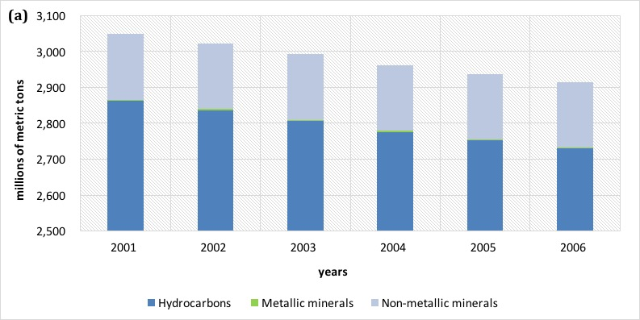 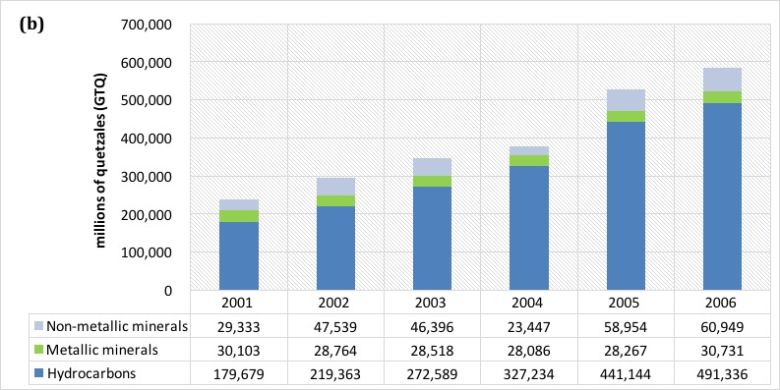

*Figure 6. Opening stock performance a) physical and b) monetary (million metric tons and million GTQ)*

## What are the economic benefits of extracting subsoil resources?

In Guatemala, from 2001 to 2006 there was a flow of subsoil resources ranging between GTQ 3,392 million and GTQ 5,014 million, at each year’s prices. During the analysis years, industries related these resources increased their contribution to the Guatemalan economy by 90%, going from GTQ 2,852 million in 2001 to about GTQ 5,427 million in 2006. Full time equivalent jobs went from 64,236 to 87,025 annually in the same years. Over 40,000 of these jobs were generated in the non-metallic minerals extraction industry. In the case of exports, there is a clear jump from 2005 to 2006 due to the beginning of operations in gold mining from GTQ 1,835 million to GTQ2,768 million. But from all subsoil resources, oil production represented 66% of the value of exports in 2006, while gold and silver represented 27% and 5%, respectively.

All industries related to subsoil resources contributed between 1.94% and 2.34% of GDP annually in the analysis years. From these, the largest value corresponds to products from non-metallic minerals, which averaged 1.05% of GDP. Oil extraction showed the most dynamic performance, going from 0.27% of GDP in 2001 to 0.65% in 2006; an annual average of 0.53% in all six years. The remaining industries represented about 0.20% of GDP annually.

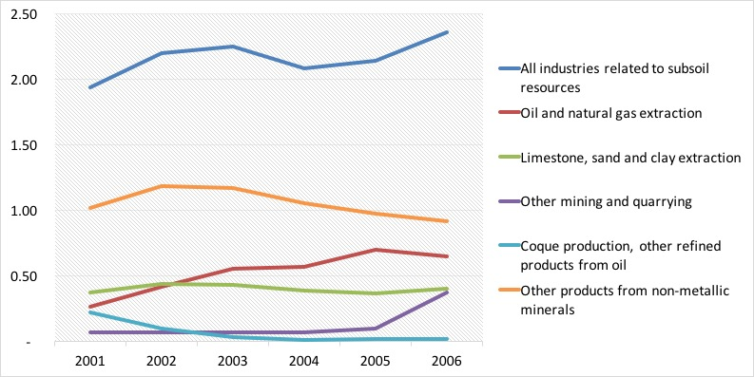

*Figure 7. Industries related to subsoil resources and their contribution to wealth (percentage of GDP)*

## Summary

In this essay we introduced environmental and economic accounting of subsoil resources as a framework that provides information on the availability of stocks of these resources and how they are used by the economy. Some interesting findings of this exercise reveal that:

* Between 2001 and 2006 the extractive industries, both local as well as foreign, supplied an annual average of 50 million metric tons of hydrocarbons, metallic minerals and non-metallic minerals, of which, about 95% come from national companies and 5% from imports.
* About an annual 44% of these resources were used as inputs in the production of other goods and services, while 34% became exports, 22% gross capital formation, and 1% went directly to households.
* Oil refining represented about 47% of total physical use of natural resources in 2006, or 10 million metric tons, a jump from only about 8% the year before.
* Owing to subsoil resources, about GTQ 3,702.5 million moved through the economy annually between 2001 and 2006. This represented between 1.94% and 2.34% of GDP.
* Each job in the industries linked to subsoil resources generated about GTQ 55,702 as contribution to Guatemalan wealth.

Waste: Waste accounting in Guatemala

*Between 2001 and 2006, the Guatemalan economy generated an average of 97.5 million metric tons of solid waste annually. Of this total, 98% came from the production of goods and services, and only about 2% from households.*

Table of Contents

What is an environmental account for waste? 63

What do we know about waste production in Guatemala? 63

What type of residuals are considered by the waste account? 64

How is waste reused and what do we know about its management? 66

So, how much waste goes straight to the environment? 68

What’s the situation of waste management? 68

How intense is waste disposal relative to wealth generation? 69

Summary 70

## What is an environmental account for waste?

The environmental account for waste is a framework that describes in detail the production, reuse, disposal and the various types of residuals generated by the different stakeholders in the economy. It makes a link between information on solid residuals and economic indicators. More specifically, it:

1. Records the physical flows of residuals from the economy to the environment and within the economy.
2. Accounts for the level of expenditure made by the government for the management of residuals.
3. Provides a set of indicators in order to monitor economic performance and waste production.

## What do we know about waste production in Guatemala?

One of the first findings when putting together this framework is that waste is a growning problem. Between 2001 and 2006, waste production grew over 70%, going from 81.9 million metric tons in 2001 to 113.8 million in 2006. Waste production by economic industries grew a total of 39.4% during those years, while that of households reached 12.4%. While economic growth is important, we have to acknowledge the increase in waste that that represents and define clear waste management strategies and market rules.

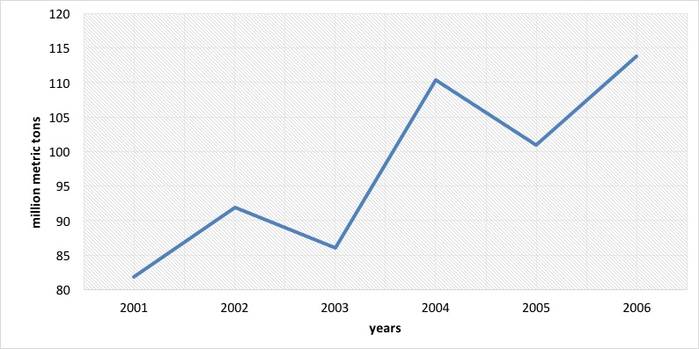

*Figure 1. Waste production trend in Guatemala 2001-2006 (million metric tons)*

It is interesting to note that the single industry with the most waste production is the manufacture of meat products which grew steadily between 2001 and 2004, with a slight decrease in 2005. Another relevant industry is the manufacture of chemical products, which tripled its waste production between 2001 and 2006, and in the case of the non-metallic mineral extraction industries we estimated an increase in waste from 10.1 million metric tons in 2001 to 13.8 million in 2006. Agriculture remained stable with 12.7 million metric tons in 2001 and 13.5 in 2006.

## What type of residuals are considered by the waste account?

Waste comes in a variety of forms, and because of this it is important that we use a consistent classification that allows us to compare and monitor over time. The waste account provides estimates for:

* Biological-infectious waste.
* Metallic waste.
* Non-metallic waste.
* Discarded equipment.
* Manure.
* Vegetable and animal waste.
* Muds.
* Mineral waste.
* Mixed waste.
* Stabilized residuals.
* Other residuals.

In Guatemala, the top producers of waste are manufactures (53.8 million metric tons), and agriculture (19.1 million metric tons). In the first case, the most relevant individual industries were the production of meat products, the production of canned and preserved fruits and legumes, sugar milling, and the production of non-alcoholic beverages, while in the case of agriculture traditional and non-traditional crops were the most important. Some of the most important levels of solid waste output are summarized by selected industries below:

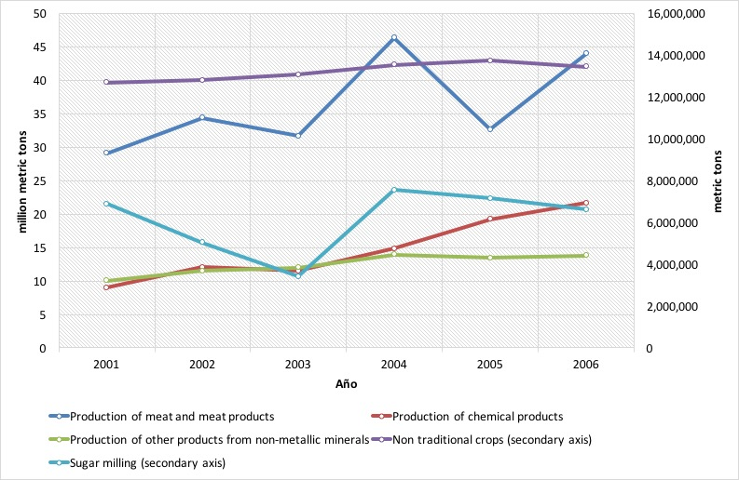

*Figure 2. Solid waste output in Guatemala 2001-2006 (million metric metric tons)*

Muds are an interesting residual, produced mainly by the chemical industry and to a minimum extent by sugar milling. In 2006 this type of waste reached 22.5 million metric tons.

Mineral waste is mainly produced by manufactures as well; specifically, by the production of other non-metallic products. In 2006 a total 13.8 million metric tons of this waste were produced. Other mining industries also contributed to this total. In 2006 non-metallic waste reached 1.6 million metric tons, mainly due to rubber and plastic production among the group of manufactures. Interestingly, households contributed 0.5 million metric tons to this category and, also relevant, sugar milling contributed 0.4 million metric tones of stabilized waste.

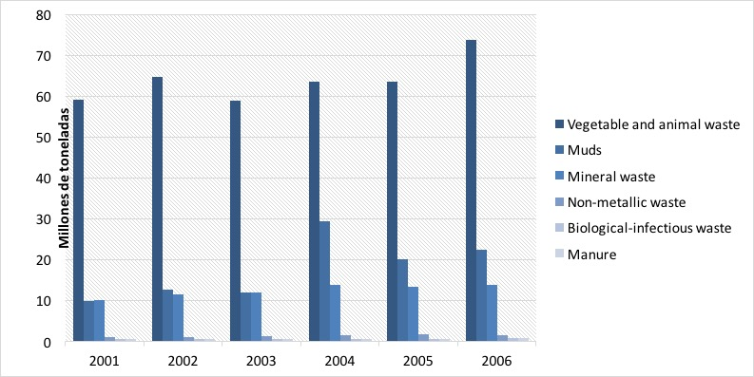

*Figure 3. Solid waste output by selected types 2001-2006 (million metric metric tons)*

## How is waste reused and what do we know about its management?

The Guatemalan manufacturing industries are the largest re-users of the various types of waste. While reuse showed a general stable trend, towards the last year of analysis (2006) there was a relevant spike, reaching about 10 million metric tons. This number is 44% higher than that of 2001 and 36% higher than that of 2005. The production of electricity is also important in the reuse of waste with about 6 million metric tons in its highest year—2004. A distant third, the industries related to agriculture fluctuate around a reuse of a million metric tons. Households and service industries reused waste at a much lower scale.

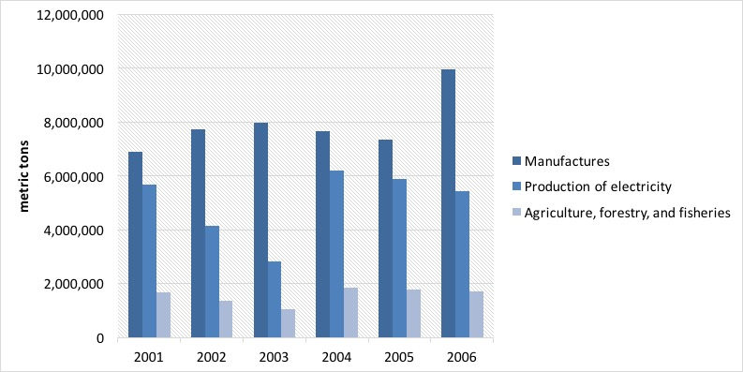

*Figure 4. Waste reuse by groups of industries 2001-2006 (metric tons)*

When we breakdown waste reuse by type, we see that vegetable and animal waste takes up the largest share of this total with 15.5 million metric tons, mainly attributed to the reuse of sugar cane bagass by the electricity production industry. Other important residuals are muds, manure, and stabilized residuals, which are used in their entirety by agriculture, forestry, and fisheries (0.8, 0.5, and 0.4 million metric tons, respectively). In average, about 15% of waste is reused in Guatemala; in 2001 this value reached about 17%, with the lowest value being 14% in 2003.

***Table 1. Waste reuse by type of waste in 2006 (metric tons)***

|  |  |  |  |  |  |  |  |
| --- | --- | --- | --- | --- | --- | --- | --- |
|  | (1) | (2) | (3) | (4) | (5) | (6) | Total |
| Biological-infectious waste | - | - | - | - | 4,041.4 | - | 4,041.4 |
| Discarded equipment | - | 5,443.1 | - | - | - | - | 5,443.1 |
| Stabilized residuals | 413,581.3 | - | - | - | - | - | 413,581.3 |
| Manure | 463,433.0 | - | - | - | - | - | 463,433.0 |
| Muds | 827,162.6 | - | - | - | - | - | 827,162.6 |
| Vegetable and animal waste | - | 9,974,261.4 | 5,436,292.9 | 19,659.2 | - | 26,803.5 | 15,457,017.0 |
| Total | 1,704,176.9 | 9,979,704.5 | 5,436,292.9 | 19,659.2 | 4,041.4 | 26,803.5 | 17,170,678.5 |

“(1) Agriculture, forestry, and fisheries; (2) Manufactures; (3) Electricity; (4) Wholesale and retail trade; (5) Real estate, businesses; (6) Households and other final consumption.

Source: Iarna/Banguat (2009)

## So, how much waste goes straight to the environment?

The difference between that which becomes waste, and the fraction that is reused goes straight to the environment. In the case of Guatemala, the largest flow of waste to the environment is vegetable and animal waste; about 58.3 million metric tons, or about 60% of total residuals. Manufactures contribute the most of these types of waste with about 44 million metric tons, followed by the group of agriculture, forestry, and fisheries with 19 million metric tons. Muds are second in importance, which represent about 22% of total waste disposal, and are the sole responsibility of industries. Mineral waste represents 14% of total disposal, and is also a flow that comes from manufacturing industries (13.7 million metric tons). Finally, non-metallic waste is also relevant, with 1.6 million tons, but it only represents about 2% of total disposal, and it is contributed by manufactures and households.

## What’s the situation of waste management?

Among other things, waste management depends on the level of public expenditure allocated for it. In 2006, that value reached GTQ 1.4 billion, of which 56% comes from departmental governments, 33% from local municipalities, and 11% from the central government. In this last case, this type of expenditure represents only 0.4% of total environmental expenditure made by the central government, and for departmental and local governments 3% and 1%, respectively. Waste management reaches about 1.3% of total country environmental expenditure.

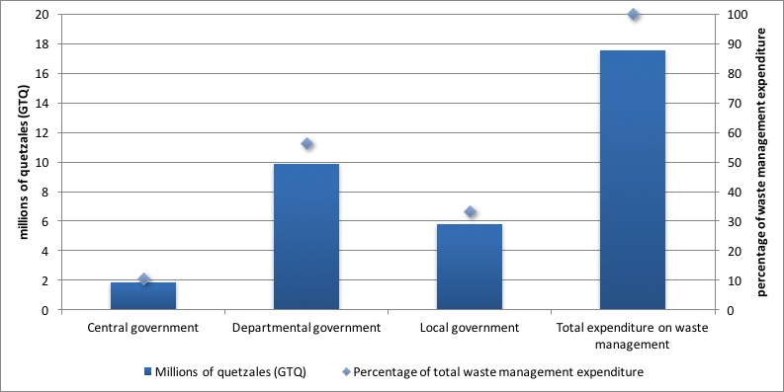

*Figure 8. Environmental expenditure destined to waste management (millions of GTQ and percentages)*

## How intense is waste disposal relative to wealth generation?

It is possible to evaluate the amount of waste generated for every monetary unit of value added (quetzales) contributed to GDP. In 2004 this intensity reached its highest point with 527 metric tons of waste per unit of value added, and by 2006 that number had dropped to 443 metric tons. This means that the pressure on the environment in terms of waste is relatively high.

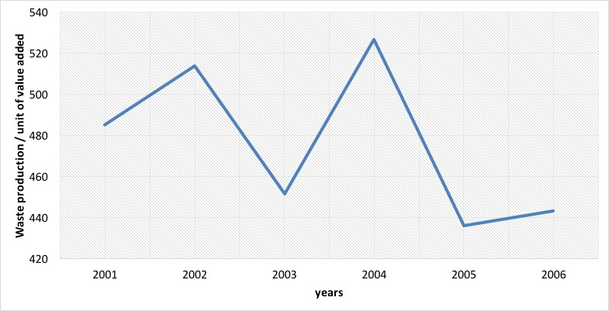

*Figure 9. Waste intensity (waste output / value added)*

## Summary

In this essay, we introduced a framework for the analysis of waste disposal at a national level, based on the System of Environmental and Economic Accounts. The waste account of Guatemala describes in detail the production, reuse, disposal and the various types of residuals generated by the different stakeholders in the economy. It makes a link between information on solid residuals and economic indicators. From its findings, we found relevant that:

* Between 2001 and 2006, the Guatemalan economy generated an average of 97.5 million metric tons of solid waste annually. Of this total, 98% came from the production of goods and services, and only about 2% from households.
* The largest producer of waste was the meat processing industry with 43.9 million metric tons disposed annually in average. This corresponded to about 37.8% of total waste disposal.
* Other important contributors to total waste are the chemical industry, non-traditional crops, non-metallic mineral production, and sugar production.
* The types of residuals with the highest levels of output were: vegetable and animal waste (63.9 million metric tons in average); muds (17.7 million metric tons); and mineral waste (12.5 million metric tons).
* Some residuals were reused by the Guatemalan economy as inputs in production processes. In 2006, 17.1 million metric tons were reused. The food processing industry became the largest user of residuals (7.4 million metric tons or 51% of total use). The generation of electricity followed closely with 5 million tons, or about 34% of total use.
* Vegetable and animal residuals were the most reused types of waste in the economy (15.5 million tons), mainly by manufactures and the production of electricity.
* Total expenditure in waste management was close to GTQ18 million in 2006. Of this total, 56% came from departmental government (provinces), 33% from local government (municipalities), and 11% from central government; about 1.3% of total environmental expenditure of Guatemala.

Water: Water accounting in Guatemala

*Water accounting showed that upward of 98% of the water used by the economy is not taken into account by our usual economic performance measures, leading to poor economic decisions with regards to this natural resource.*

Table of Contents

What is a water account and what is it for? 72

What are the general trends regarding water interactions in Guatemala? 72

But, what do we know about the water use of other industries? 74

Do we have information on agricultural uses of water? 76

How about industrial uses of water? 77

What do we know about water uses of other industries and consumers? 78

How is this information different from what we already know from National Accounts and other sources? 78

Summary 80

## What is a water account and what is it for?

The water account of Guatemala is a framework with which we describe the intricate relationships between the economy and the use of water as a natural resource. Information on water sources is linked with information about the various stakeholders in the economy, such as industries and consumers. More specifically, the water account:

* records the availability of water information the country;
* records the different flows of water between the economy and the environment, and within the economy, as well as between stakeholders;
* Accounts for expenditures made in order to safeguard and restore water sources;
* Provides a set of indicators suited to monitor the environmental and economic performance of the economy.

## What are the general trends regarding water interactions in Guatemala?

We first turn to the use of water, which we can understand as either consumption of water in processes that delay its return to the water cycle, such as household uses, industrial uses, and agricultural uses, as well as its use in processes that return it immediately to the environment, such as electricity generation. Figure 2 shows some variation in the use of water between 2001 and 2006 and results suggest that a slowdown of the production of coffee at the beginning of the decade might have contributed in a relevant manner to this behavior.

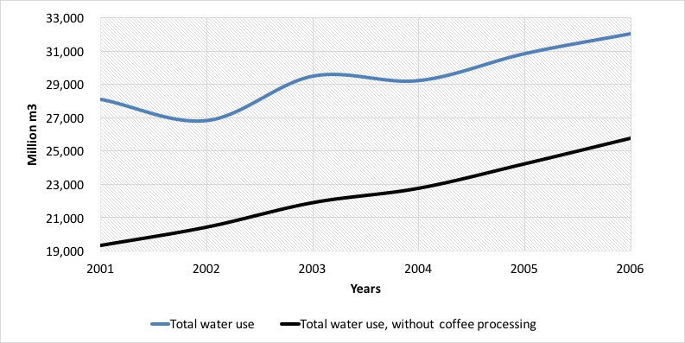

*Figure 1. National water use with and without coffee processing (million m3)*

The coffee processing industry is one of the largest users of water in Guatemala. In fact, next to the production of corn, which is highly dispersed among small landowners, coffee is one of the crops that covers more surface area in the country. However, data from the National Coffee Producers Asociation (ANACAFE) show that coffee production, which reached close to 286 thousand metric tons in 2001, saw a 27% drop the following year, bouncing back in 2003, but stabilizing at a lower 204 metric tons for the remainder of the analysis period. Notwithstanding, if we remove the data corresponding to coffee from the series (which we can also see in figure 2), then the trend of water use by the remaining industries was of steady growth.

Another interesting indicator is that of water use per capita. This indicator links total water use to a population headcount for each year. Table 7 shows this indicator for our accounting years. It is evident that water use per capita reached its most significant number in 2006 with a total of 2,459 m3 per inhabitant.

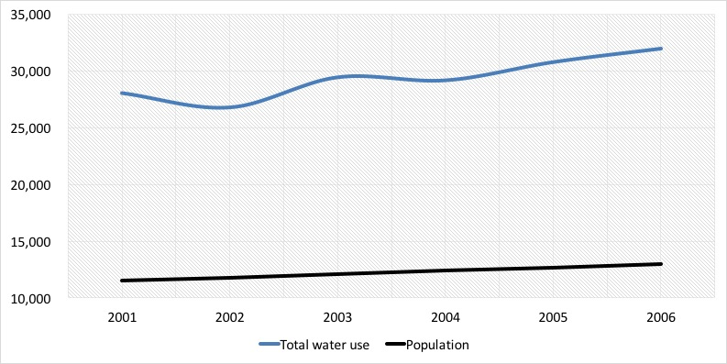

*Figure 2. National water use (million m3) and population (thousands of inhabitants)*

Figure 2 shows an erratic behavior in the use of water with a steady growth of 2.5% of the Guatemalan population. This suggest that population growth is a poor indicator of water use variation. If we don’t take into account the processing of coffee, water increased at a rate of between 4% and 7% between 2001 and 2006, a trend which is likely to continue in the future.

## But, what do we know about the water use of other industries?

To answer this question, we first turn to the agricultural industries. In our analysis, we took into account the rain water that was used by crops in their different growth stages. This is called rainfed irrigation and we chose to include it because it reflects the real contribution of water to our economy in a better manner. Figure 4 shows the trend of the largest water using industries of Guatemala. As expected by the introduction above, rainfed agriculture is the largest of all water using industries, with a share of about 40% of total use. It is followed by manufactures, which used between 35% and 24% in the accounting years.

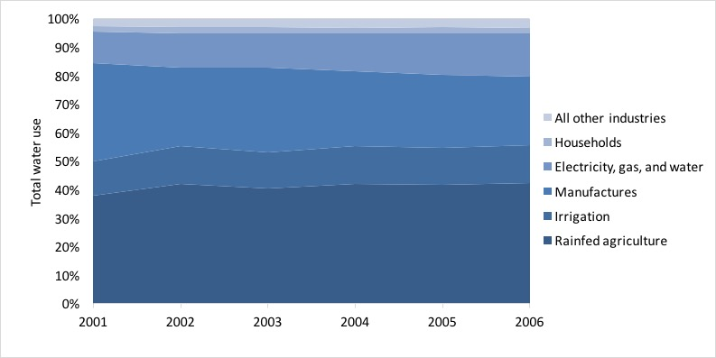

*Figure 3. Shares of water use for selected industries (percentages)*

Electricity generated with hydraulic power gained importance in the accounting period, going from about 11% in 2001 to 15% of total water use in 2006. In contrast to the figures presented before, irrigated agriculture represented about 10% of national water use in 2006, and about of 25% of the water used by all agriculture in general (about 4.3 million m3 in 2006).

Interestingly, households used less than 1.5% of total water use in Guatemala, and the remaining industries hovered around 3% and 4% annually.

As we explained before, the total amount of water used above includes rain water. However, there is also the concept of water extraction, which corresponds to water from an underground or surface source, and at the same time represents a consumption or severe change in its quality. This implies that neither hydroelectricity production or rainfed agriculture fit this description.

Figure 5 shows manufactures as the main extracting activities with a share of 62% of all extraction in 2003, which is estimated at 14,038 million m3. Another important industry in this sense is irrigated agriculture, which was responsible for about 27% of total extraction in 2003. Coffee processing followed with 54% of extracted water, and sugar cane growing with about 12%. Households represented less than 3% of total water extraction in Guatemala.

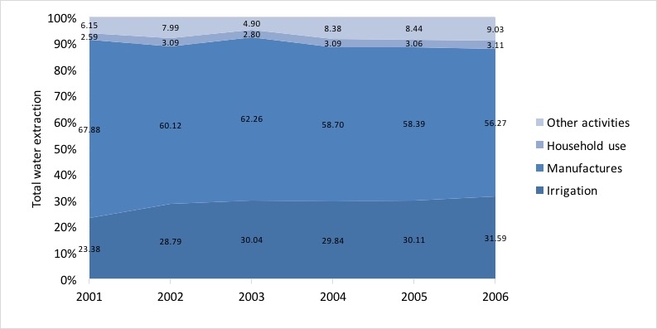

*Figure 4. Water extraction for selected industries (percentages)*

## Do we have information on agricultural uses of water?

The amount of water used by different crops depends on the different requirements of each cycle of plant growth, total cultivated area, total area under irrigation, and irrigation methods used. Table 1 shows estimates for the most important crops in Guatemala. This group represented about 87% of total water used by agriculture and 75% of the demand of water for irrigation in 2003. In this sense, sugar cane production stands out with 43% of total irrigation.

***Table 1. Water used by the most important crops in Guatemala. (million m3 and percentages)***

|  |  |  |  |  |
| --- | --- | --- | --- | --- |
|  | **Rainfed agriculture** |  | **Irrigated agriculture** |  |
|  | **Volume** | **Percentage** | **Volume** | **Percentage** |
| Banana | 308,485,229 | 2.59 | 517,090,909 | 13.69 |
| Coffee | 2,541,335,533 | 21.35 | 0 | 0.00 |
| Sugar cane | 2,089,164,485 | 17.55 | 1,636,521,421 | 43.34 |
| Cardamum | 674,366,183 | 5.66 | 0 | 0.00 |
| Beans | 932,256,561 | 7.83 | 0 | 0.00 |
| Maize | 3,820,696,316 | 32.09 | 0 | 0.00 |
| Mango | 87,470,637 | 0.73 | 80,795,454 | 2.14 |
| Melon | 31,868,075 | 0.27 | 126,376,488 | 3.35 |
| African palm oil tree | 421,783,476 | 3.54 | 469,444,799 | 12.43 |
| These crops | 10,907,426,494 | 91.62 | 2,830,229,071 | 74.96 |
| Other crops | 997,502,349 | 8.38 | 945,661,520 | 25.04 |
| Total Agriculture | 11,904,928,843 | 100.00 | 3,775,890,591 | 100.00 |

Source: Iarna/Banguat (2010)

Regardless of whether crops are irrigated or not, it is evident that water is of extreme importance to food security (staple foods) and exports (sugar cane and coffee).

## How about industrial uses of water?

Manufacturing industries used around 8.7 million m3 of water in 2003. Table 9 shows selected industries with the largest uses. Once again, coffee processing stands out with an 87% share of all water used by manufactures (about 7.6 million m3). Other important groups of manufacturing industries are food production and sugar production with around 8% and 2.5% of total water used by manufactures, respectively.

## What do we know about water uses of other industries and consumers?

It is important to point out that the third largest use of water in the country is the production of electricity. This industry may only use water and not consume it, but its final product—electricity—makes a relevant contribution to the generation of wealth in the economy (or gross domestic product). In 2001 the share of total water use of electricity production was 11% and it grew to 15% towards the end of the analysis years; in 2006.

On the other hand, water used to satisfy direct human needs represented around 3% of total extraction in the years 2001-2006. In 2003, total water used by households was estimated at 392.7 million m3. We made this calculation taking into account that water use varies from urban to rural areas, from administrative region to region in the country, and also given different kinds of access to water of households. Table 10 shows these results by department. A total of 59% of all household consumption of water happens in urban areas, and about a third of national household water is used in the department of Guatemala, where the capital city is located; the largest in the country.

***Table 3. Household water use for selected departments; urban and rural areas. (million m3)***

|  |  |  |  |
| --- | --- | --- | --- |
| Department | Urban | Rural | Total |
| Guatemala | 120,877 | 13,035 | 133,912 |
| Alta Verapaz | 6,238 | 17,828 | 24,067 |
| San Marcos | 6,903 | 16,061 | 22,964 |
| Quetzaltenango | 13,727 | 7,178 | 20,905 |
| Escuintla | 9,542 | 8,784 | 18,326 |
| Huehuetenango | 6,351 | 10,660 | 17,012 |
| Rest of departments | 69,036 | 86,472 | 155,509 |
| Total | 232,674 | 160,018 | 392,695 |

Source: Iarna/Banguat (2010)

## How is this information different from what we already know from National Accounts and other sources?

In the System of National Accounts of Guatemala only water that is the subject of economic transactions is recorded, and given the institutional framework of water access in Guatemala, most water uses do not fit that category. Most rain water and water extracted from wells for own use in industry and some residential complexes is not the subject of payments between economic stakeholders, and so it is not recorded by the system of national accounts. There is however an exception, and that is the small fraction of water that is channeled through municipal or private distribution companies and which is charged to some connected households and small to medium enterprises.

From our exercises already presented above we were able to compare and contrast the different volumes estimated by the System of National Accounts and water accounting. Figure 8 shows that upward of 98% of water is not recorded by our usual economic performance measures. In 2006, this represented over 31 million m3.

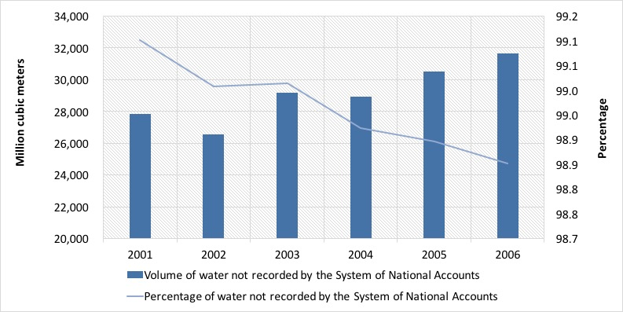

*Figure 5. Water not recorded in the System of National Accounts*

Furthermore, table 11 shows these differences for selected individual industries. For example, in agriculture over 80% of unregistered water corresponds to rainfed agriculture, but the grand majority of water for irrigation is also excluded from typical gross domestic product calculations. And even for households, which are the main clients of private and municipal water distribution systems, recorded water only accounts for about 20% of their total use.

***Table 3. Water not recorded by SNA for selected industries (million m3)***

|  |  |  |
| --- | --- | --- |
| Selected industries | Recorded by SNA | Not recorded by SNA |
| Coffee production | 37,120 | 2,541,335,533 |
| Banana production | 0 | 825,576,138 |
| Cereals production | 0 | 4,013,236,479 |
| Production of other crops (including sugar cane) | 736,978 | 3,944,990,546 |
| Coffee processing industry | 0 | 7,591,184,951 |
| Food processing industry | 1,344,646 | 687,756,805 |
| Sugar production | 1,758,014 | 217,000,000 |
| Electricity generation | 220,152 | 3,546,433,255 |
| Households | 62,175,931 | 330,560,455 |

Source: Iarna/Banguat (2010)

## Summary

We have described the importance of water for various production and consumption processes in the economy using the framework of the System of Environmental and Economic Accounts.

For most economic industries water use had a growing trend, with the exception of coffee production—the largest individual user of water—. Due to external shocks in international coffee markets, there was a significant drop in production of this commodity, which in turn translated into a lower demand for water for the entire Guatemalan economy.

In 2006, water use per capita reached a total of 2,459 m3 per inhabitant. This is closely related to total household water consumption, which interestingly was less than 1.5% of total water use in Guatemala in that year.

There is a difference between water use and water extraction. The latter implies an abstraction of water from the natural environment. About 56% of all water extraction can be attributed to manufacturing industries in 2006, with about 30% going to irrigated agriculture. All the other industries and services and households account for the remaining share of about 12%.

It is interesting to note that coffee processing is by far the industry that uses the most water, with a share of about 86% of total water use. This knowledge is key for the design of better public policies regarding irrigation districts, and forest incentives in order to protect water sources and increase water provision.

Regarding the effectiveness of SNA to capture interactions between the economy and the environment, our data show that upward of 98% of water is not recorded by our usual economic performance measures. In 2006, this represented over 31 million m3. Since macroeconomic performance measures are used by economic agents to make decisions, the oversight of such a large amount of water use might lead to unsustainable economic decisions and to supply shocks in the future.

1. Renato Vargas with support from WAVES and IARNA-University Rafael Landívar.